**May 31st Edition:**

**Published by select members of the Success Skills and Yearbook classes.**

**Are you going on any trips this summer?**

byJustine Daniel

*(Teachers and Staff)*

**Ms. Veva:** I am going to LA, Barcelona, and Ibiza (Spanish Islands off the coast of Spain).

**Ms. Tania:** I am going to LA and Hawaii.

**Ms. Crystal:** I am going to Disneyland, Redwoods National Park, and the Grand Canyon.

**Mr. Coomler:** I am going to go fishing in Eugene, Oregon.

**Mrs. Huerta:** We are deciding whether we should go to Banff, Canada, Bodega Bay, California, or Chicago.

**Mr. Scozzafava:** I am going to San Diego and Minnesota.

**Ms. Holmes:** I am going to go Rafting down the Salmon River in Idaho and Bend, Oregon to visit my daughter.

**Mrs. Diaz:** I am going to spend a little time in Roseville, and in October I am going to Hawaii.

**Mrs. Harrell:** No, I am staying in Incline.

**Mrs. Walker:** I am going to Vegas, but other than that no traveling.

**Mrs. McGill:** We are going to Wyoming with some friends to go camping.

**Mrs. Conroy:** I am going to Santa Cruz.

**Mr. Vaughan:** I am going on a road trip to Colorado, Utah, and Wyoming.

**Mrs. Gentner:** I am going on a few short trips to Baja, Mexico to work on my house there.

**Ms. Therese:** I am going to a family reunion in Virginia.

**Mr. Snearly:** Maybe.

**Spring Jokes**

by Jayden Jenkins

Why did the flower crash his bicycle? - *He lost control of the petals.*

It’s springtime already? *You’ve got to be pollen my leg.*

Why is the letter “A” like a flower? *Because a B comes after it.*

How do you kiss in spring? *With tulips!*

How do bees brush their hair? *With honeycombs.*

Where did the egg go for spring break? *New Yolk City.*

Why can’t the duck go to the comedy show? *Because he’ll quack up.*

How does the sun listen to music? *On the ray-dio.*

What do you call a bear that got caught in a spring shower*? A drizzly bear.*

Why are all the birds flying to Florida? *They're going on spring beak.*

Does February like March? *No, but April May.*

Why do florists love springtime? *Business is blooming!*

Why are flowers so popular? *They have a lot of buds.*

Why did the bird go to jail? *For robin the bank.*

What’s the best place to plant flowers at a school? *In Kinder-garden.*

Why is April so clean? *Because April showers.*

Sources: https://www.today.com/life/inspiration/spring-jokes-rcna149210

**Summer Countdown:**

*(As of May 31st)*

8 Days of school left and 1 half day!!!

Can you believe it??!!

**Summer Recipe of The Week**

By Mya Miller

Pina Colada Dip

**Ingredients:**

· 1-1/4 cups cold 2% milk

· 3/4 cup pineapple yogurt

· 1 package (3.4 ounces) instant coconut cream pudding mix

· 1 carton (8 ounces) frozen whipped topping, thawed

· Optional: Toasted unsweetened coconut flakes and maraschino cherries

· Fresh pineapple wedges

· Vanilla wafers

**Directions:**

1. In a large bowl, whisk milk, yogurt and pudding mix 2 minutes (mixture will be thick). Fold in whipped topping. Refrigerate, covered, for at least 2 hours.

2. If desired, top with coconut and cherries before serving. Serve with pineapple and wafers.

**Jokes**

by Alva Pitts

Q: Why did the cell phone get glasses?

A: Because she lost all her contacts.

Q: How did the mobile phone propose to his girlfriend?

A: He gave her a ring.

Q: What’s the most popular video game at the bread bakery?

A: Knead for Speed.

Q: Why is Santa good at karate?

A: He has a black belt.

Q: Where do werewolves buy Christmas gifts?

A: Beast Buy.

Q: What did the snowflake say to the road?

A: Let’s stick together.

Q: Why did the turkey join a band?

A: So he could use his drumsticks.

Q: What’s a math teacher’s favorite winter sport?

A: Figure skating.

Q: Where do werewolves buy Christmas gifts?

A: Beast Buy.

Q: What did the snowflake say to the road?

A: Let’s stick together.

Q: Why did the turkey join a band?

A: So he could use his drumsticks.

Q: What’s a math teacher’s favorite winter sport?

A: Figure skating.

Q: What’s a firefly’s favorite dance?

A: The glitterbug.

Q: Where do roses sleep at night?

A: In their flowerbed

Q: Why was the show bad at gymnastics?

A: She was a flip-flop

Q: What should you wear to a tea party?

A: A t-shirt

Q: What’s rain’s favorite accessory?

A: A rainbow

Q: Where does a sink go dancing?

A: The dish-co

Q: Why did the Genie get mad?

A: Because he was rubbed the wrong way.

Q: What’s a ballerina’s favorite type of bread?

A: A bun.

Q: What kind of dance was the frog prince best at?

A: Hip hop.

Q: What do bunnies like to do at the mall?

A: Shop ‘til they hop.

Q: What is corn’s favorite music?

A: Pop.

Q: Why can’t Monday lift Saturday?

A: It’s a weak day.

Q: Why was the politician out of breath?

A: He was running for office.

Q: What is a soccer player’s favorite chemical element?

A: Goooooooooooold!

Q: Why did the fastest cat in class get kicked out of school?

A: He was a cheat-ah.

Q: Which state has the greatest number of jokes?

A: Pennsylvania.

Q: Where is the best place to sit when a submarine is diving?

A: Inside.

Q: Why did the lawyer show up in court in his underwear?

A: He forgot his lawsuit.

**Top 5 Artists (in no particular order)**

by Alva Pitts

Mr. V: ACDC, Grateful Dead, Led Zeppelin, The Rolling Stones, and Sublime

Emy: Camping in Alaska, Kanye, the Smiths, Suicide Bois, and Lil Peep

Kahea: dd Osama, Hattie Osama, ebkjaaybo, XXX Tentation, and Sha Jizz

Ryker: Eminem…

Steven Kendrick Lamar, The Weeknd, Travis Scott, Drake, and Playboi carti,

Jesus: Kendrick Lemar, the weekend, and Ureza,

Mrs. Huerta: Hall and Oats, Zack Brian, Keith Urban, Stevie Wonder, and Micheal Bublé

Byron: Playboi carti, Travis Scott, Kendrick Lamar, Chinopacas, and Fuerza Regida

Blake: Playboi carti

**Experiences Creating and/or Reading the Newspaper**

by Alva Pitts

Mr. Vaughan: It is a lot of work writing, editing, designing, formatting, printing, collating, stapling, and distributing. Uggg!

Emy: She “loooooooooves” schoolwork!!!

Blake: does not like writing articles

DJ: boring

Sarah: boring sometimes

Itzel: fun

Kyler: chill

Steven: good

Mrs. Gentner: 8/10

Theo: good job

Mr. G: Yeah, a good job for middle schoolers.

**Backpack effects on…**

by Alva Pitts

Emy: doesn't care

Kahea: $u**s, because he hates lockers

Gisselle: bad

Brayan: doesn't matter

Angel: doesn't care

Theobedsheet: S*%ks, wishes he had backpacks

Mrs. Gentner: doesn't agree with the rule

Steven: bad and stupid for no reason

Reeve: so terrible

Tucker: hates it

Itzel: it’s sooooooo weird.

Sarah: annoying carrying everything

Levi: made it way harder to be in school and scared of being stolen from

Alva: veeeeeeeeeeeeeeeeeeeeeeeeeeeeeeeeeeeeeeeeeeeeeeeeeeeeeeeeeeeeeeeeeeeeeeeeeeeeeeeeeeeeeeeeeeeeeeeeeeery annoying.

**Spirit Week: June 3-7**

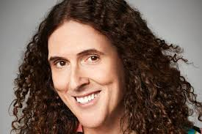by Katie Nelson

**Monday, June 3** - Western day, dress up as a cowboy or cowgirl.

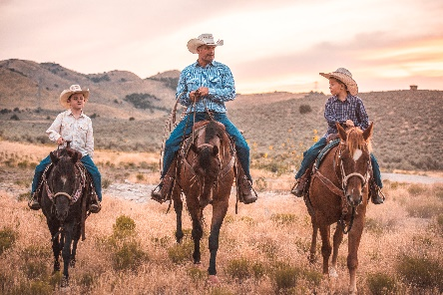

**Tuesday, June 4** - Jersey Day, wear your favorite team’s jersey.



**Wednesday, June 5** - “On Wednesdays we wear pink” (Karen Smith); just wear pink!

**Thursday, June 6** - Disney day, dress up as any Disney character, or wear anything Disney related.

**Friday, June 7** - Music Day, wear your favorite artist.

**Favorite Beach to Go to During the Summer?**

by Katie Nelson

Maria- Hidden Beach

Jayden- Incline Beach

Andes- Hidden Beach

Mya- Incline Beach

Kaylee- Incline Beach

Isabela- Burnt Cedar

Sarah- Hidden Beach

Sky- Burnt Cedar

Melissa- Incline Beach

Mr. Vaughan- Hermit Beach

Jacob- Ski Beach, Burnt Cedar

Nicole- Incline Beach

Theo- Incline Beach, Hidden Beach

DJ- Hidden Beach

JP- Incline Beach

Tucker- Hidden Beach

Lizzy- Incline Beach, Ski Beach

Angel- Hidden Beach

Lily- Incline Beach

Ashlyn- Incline Beach

**Dessert of the Week**

**Chocolate Chip Cookie in a Skillet**

by Ashlyn James

**INGREDIENTS**

· 2 ½ cups all-purpose flour · 2 teaspoons baking powder · 1 teaspoon baking soda

· ½ teaspoon salt

· 1 cup unsalted butter

· 1 cup packed brown sugar · ½ cup sugar · 1 large egg

· 2 large egg yolks

· 3 teaspoons vanilla extract · 10 ounces chocolate chips, milk or semi-sweet, your choice!

· flaked salt, for topping

**INSTRUCTIONS**

· Preheat the oven to 350 degrees F.

· In a bowl, whisk together the flour, baking powder, soda, and salt.

· Heat an oven safe (preferably cast iron!) 12-inch skillet over low heat. Let the skillet heat up for 5 minutes. Add the butter and let it melt completely. Stir in the sugars with a wooden spoon. Turn off the heat under the skillet. You MUST turn off the heat! You can also remove the skillet from the burner if you wish.

· Whisk together the egg and egg yolks in a bowl. Add it to the skillet sugar mixture and mix in right away with a spoon, quickly mixing so the eggs don’t cook from the heat. Stir in the vanilla extract.

· Stir in the dry ingredients until just combined. This will take a minute or two and the mixture will be thick, but they will mix in! You can wipe the top of the skillet or the sides with a damp paper towel to remove excess flour.

· Stir in the chocolate chips. Bake the skillet cook for 20 to 25 minutes, or until it’s mostly set in the center. Top with flaked sea salt.

· Serve warm with vanilla ice cream.

Source: Chocolate Chip Skillet Cookie - Chocolate Chip Cookie Skillet (howsweeteats.com)

**What is your favorite sport?**

by Blake Christensen

Sarah- volleyball.

Angel- soccer

Bryan- soccer

Theo- soccer

Levi- football

Madiline- swimming

Destin- swimming

John- soccer “Messi is better.”

Jacob- soccer “Messi is better.”

Issac- soccer

Rodrigo- Baseball

Gunner- Basketball

Leo Durran- Football

Salomon- Badminton

Tyler- Basketball

Ezra- Football

Maria (6th)- Soccer

Mr. Coomler- Football

Mr. Edwards- Skiing

Tania- Football

Mrs. Gentner- Motocross.

Bode- wrestling

DJ- wrestling

**What Sport(s) Do You Play?**

by DJ Galloway

Angel- Soccer

Theo-soccer and ski

Bode- Wrestling, baseball

Levi- none ☹

Madeline- swim, ski

Destin- swim, basketball

Salomon- ski, track

Blake- eating, basketball

Jacob- soccer

Rodrigo- wrestling, basketball

Mr. Edwards- ping pong, skiing

Ms. Gentner- Motocross

Alva- Whatever people make me.

Mr. Coomler- Fishing!

**Light Books to Read for Summer Reading**

by Emerson Jacob

When it comes to summer reading, 8th graders going into high school are expected to read two books and 6th and 7th graders are supposed to read one book and write an essay. If you do not have that much time, but you want to read a light book but not a lobotomy-worthy book, this is a guide! For a light easy breezy read try an R.L Stine *Fear Street* book they’re cheap and easy to read, while they almost always have a plot twist or a crazy plot line. If you want something more advanced but still a short book *The perks of Being a Wallflower* was a sad but a short easy read. Be warned it is a PG 13 book it says some naughty stuff, but it still puts interesting stuff into perspective. Another alternative is classic books. Yes, there more of a difficult read but there very rewarding my recommendations are *1984*, *To Kill a Mockingbird*, and *The Adventures of Huckleberry Finn*. Again, some say some naughty outdated terms, but they are a true American treasure. I hope this guide helped have a litty summer.

**Things to do in Incline**

by Emerson Jacob

There are not that many things to do in Incline without getting repetitive so, I am here to offer some new ideas and plans you can make this summer. Instead of going to Raley’s or Starbucks for a snack, try someplace new like Sunshine Deli or Happy Tiers Bakery. If you want to do an activity instead of going to Incline or Hidden beach you can go to Burnt Cedar for the **A crossword puzzle with words
**pool, beach volleyball, playground, or the nice part of the lake. The last idea is to pull up to your friend’s house and create your own game. Try some of my suggestions to see if it is Skibidi.

**Who is your favorite artist?**

by Blake Christensen

Tucker- Chief Keef.

**Reeve**- Drake.

**Itzel**- Frank Ocean.

**Caleb Carsman**- Tyler the Creator.

**Gunner**- NF.

**Mrs. Harrell**- Post Malone.

**Levi**- Muse.

**Austin**- Travis Scott

**Emy**- Kanye West

**Larson**- 21 Savage

**Mr. Edwards**- David Byrne

**Saige**- Playboi carti

**Alva**- Grateful Dead.

**DJ**- Hank 3 (if ya know, ya know…ya know?)

**Jacob**- Kendrick Lamar

**Mason**- Mike Sherm

**Mr. Coomler**- John Coltrain

**Kahea**- DD Osama

**What is your biggest weakness**?

by D.J. Galloway

Blake- Eating

Sarah- Dan Schneider

Giselle- Theo

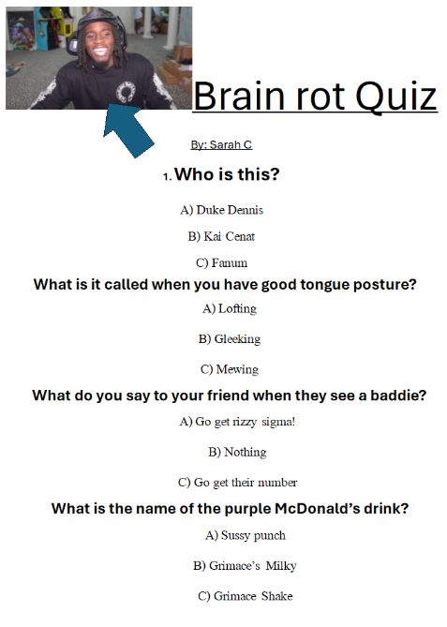Valerie- Diego

Itzel- height

Miley- white boys

Bode- D.J.

Big Southside- Milly Bobby Brown

Melissa- curly hair

Emy- TikTok shop

Mr. Vaughan- *Top Chef,* calves, and his hairline

Alva- My chest!