**Formal Geometry 3.1 Guided Notes: Reflections**

A _________________________ in a line maps a point to its image such that:

* If the point is on the line, then the _______________ and the _______-_________________ are the same point.
* If the point does not lie on the line, the line is the ______ _______________________ of the segment joining the pre-image and image.

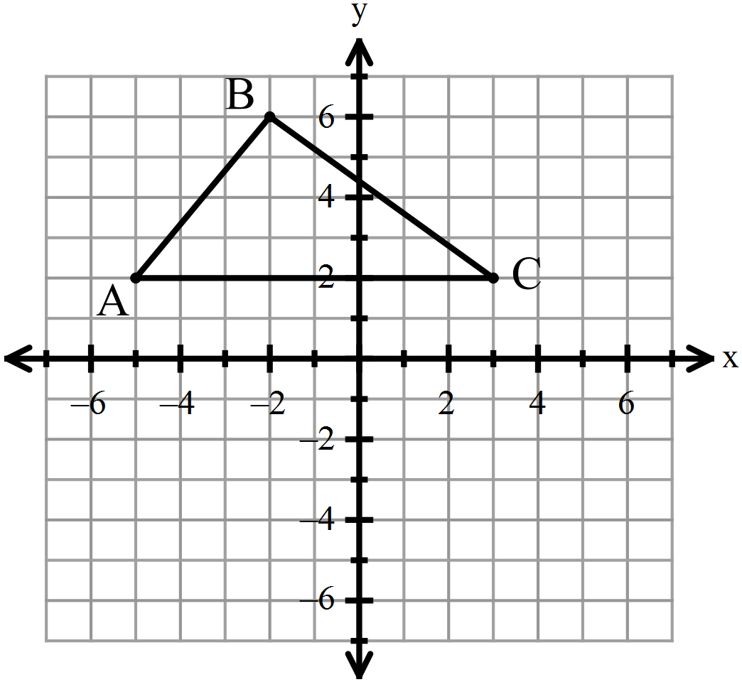Reflect the given figure in the line *y* = -1. Reflect the given figure in the line



**Reflection in the *x*-axis**: **Reflection in the *y*-axis:**

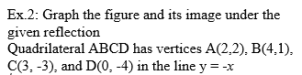Reflection in the line

 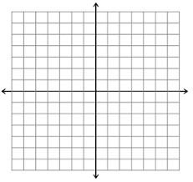

**Summary:**

**Reflection in the *x*-axis Reflection in the *y*-axis Reflection in the line Reflection in the line**

**Formal Geometry 3.2 Guided Notes: Translations**

A _________________________ maps each point to its image along a vector, such that:

* Each segment joining a point and its image has the ___________ ______________ as the vector, and
* This segment is also ____________________ to the vector.
* If you translate a point along the vector , add *a* to the ___-____________________ and

add *b* to the ___-________________________.

 Translate the given figure along Translate the given figure along

Write the translation vector for Write the translation vector for

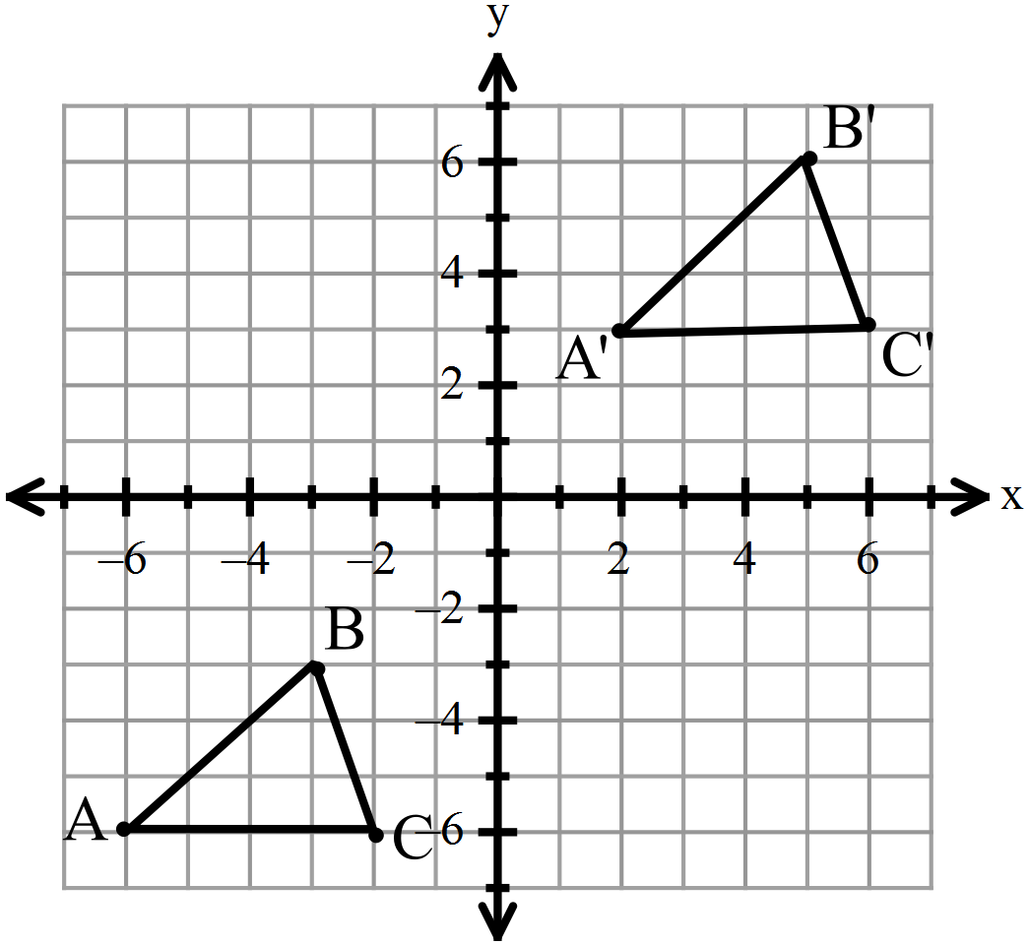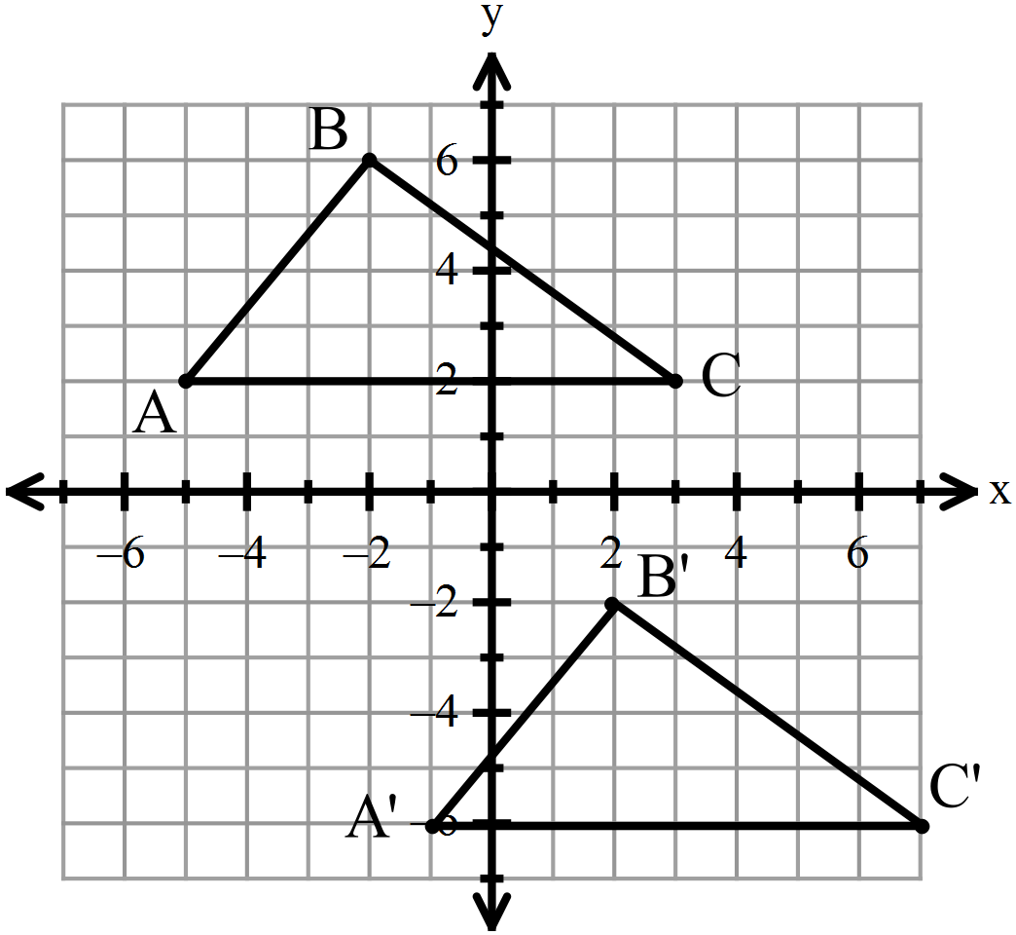

A’

B’

C’

Coordinate Notation to describe a translation:

**Example 1**: Translate the given figure along **Example 2**: Write the translation (in

. **coordinate form)** for the movement shown.

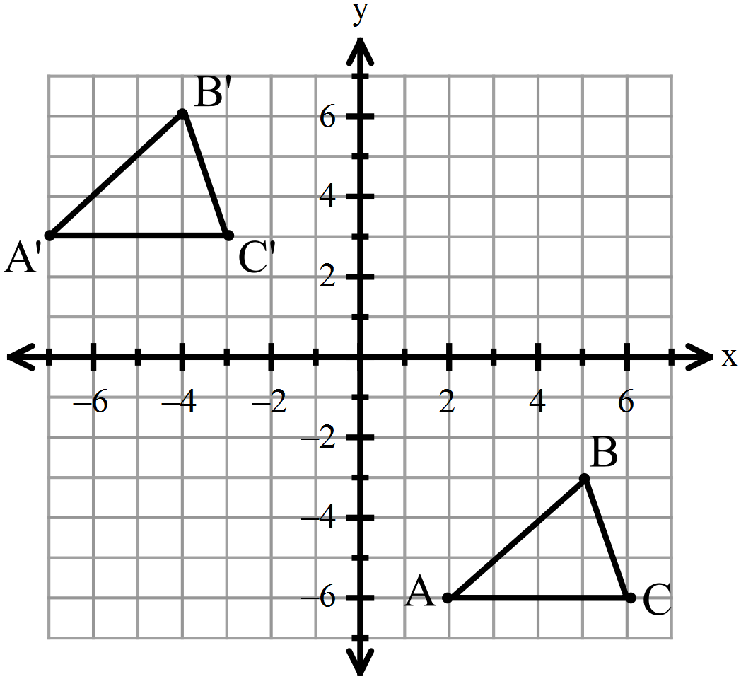

**Putting it all together:**

Lance claims the transformation below can be done **Example 3:** Draw line and point A, which is

by reflecting the preimage (in quadrant I) in the not on . Reflect A in to create . Draw

y-axis, translating along , then reflecting in points E and F on Name all congruent

the x-axis. segments in the diagram.

Sara is confident it can be done in 2 steps: reflect in

the x-axis then translate .

Joseph says that it can be translated first, then

reflected.

Who is correct?

**3.3 Notes: Rotations**

Rotations about the Origin

Clockwise: Counter-Clockwise:





**3.4 Guided Notes: Composition of Transformations**

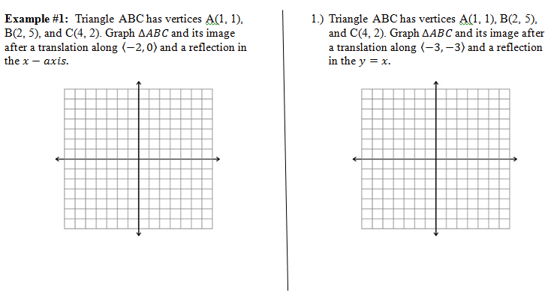

* A ***Composition of Transformations*** is when a transformation is applied to a figure and then another transformation is applied to its image.

3

**Example #2:** Graph : W(-5, 2) and X(-5, -3) and its Ex 3: Graph : A(2, -1), B(5, -2), and C(3, -4)

image after a reflection in the and a rotation and its image after a translation along

90° about the origin. and a rotation 180° about the origin.

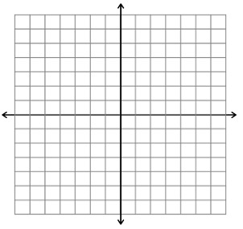

**Ex 4**: The triangle shown is reflected in line *m* and then reflected in line *p.* Draw the figure , and then describe the transformation that maps D onto in a single transformation.

D

*m*

*p*

5 inches

**Ex 5**: The triangle shown is reflected in line *m* and then reflected in line *p.* Draw the figure , and then describe the transformation that maps D onto in a single transformation.

D

*m*

*p*

28o

**Ex 6**: Graph : A(7, -4), B(5, -1), and C(9, 0). Rotate the figure 90° about the point (4, -5). Then reflect the figure over the line y =1.

What are the coordinates of ?

What are the coordinates of ?







