**Definition of a Function:**

**Function:** each input has exactly _______ output.

**Vertical Line Test:**

**Important Characteristics of a Function:**

Increasing: -interval (from left to right) where a function is going uphill

Decreasing: -interval (from left to right) where a function is going downhill

Constant function: -interval (from left to right) where a function is horizontal

Relative max: a point where a function changes from increasing to decreasing; a “mountain-top”

Relative min: a point where a function changes from decreasing to increasing; a “valley”

Domain: set of all inputs (*x*-values) for which a function is defined

Range: set of all outputs (-vaues) for which a function is defined

**Reminder:** interval notation

* Use [brackets] for closed circles and (parenthesis) for open circles
  + Exception: we will use (parenthesis) for *all* increasing/decreasing intervals
  + Some textbooks use brackets instead of parenthesis.
* For *x*-values, use ***left, right***
* For *y*-values, use ***bottom, top***
* For undefined points, such as open circles, use a parenthesis instead of a bracket.

**Example 1:** Identify the important characteristics of the graph shown.

Is the graph a function? How do you know?

Interval(s) increasing Interval(s) decreasing

Relative max, if any Relative min, if any

Domain Range

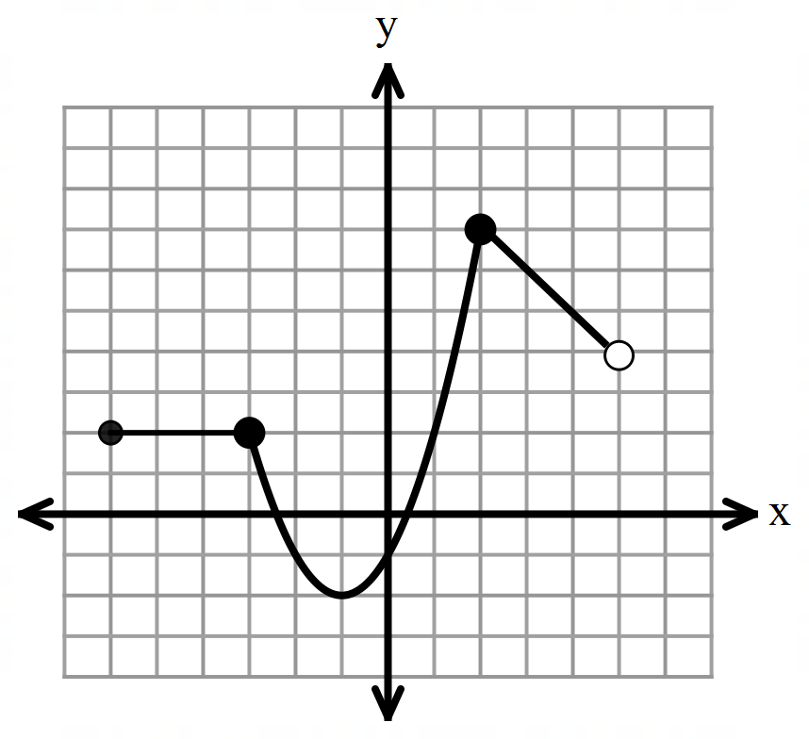

**Odd and Even Functions:**

A function is **even** if for all values of *x*.

A function is **odd**if for all values of *x*.

**Examples 2 – 4: Determine if the function is even, odd, or neither.**

2)

3)

4)

**For #5 – 7, evaluate each function at the given value of the independent variable.**

Given that and

5) 6) 7)

8) Given that , find if Simplify your answer.

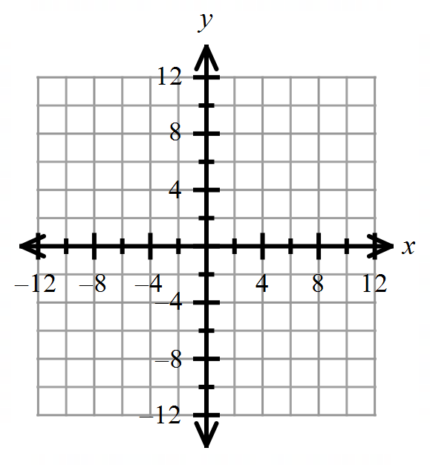

9) Graph on the provided coordinate system.

10) Write the equation of the line in point-slope form that passes through has an *x*-intercept of Also write your answer in form and slope-intercept form.

**For #11 – 13: Perform the indicated operations for the given functions for**

11) Find if . Factor your answer completely.

12) Find if

13) Find … also written as … if and

**Inverses of Functions:**

* To find the inverse of a function: exchange the *x* and *y*-variables, and solve for *y*.
* Given that and are inverse functions, and if then .
  + In other words, each ordered pair has the *x*- and *y*-coordinates exchanged.
* Given that and are inverse functions, then and are reflections in the line
* Given that and are inverse functions, then and

**If a function is one-to-one*,*** then it passes both the Vertical Line Test and the Horizontal Line Test.

* This means that both the function and its inverses are functions.
* For each input, there is exactly one output. And for each output, there is exactly one input.

14) Find the equation of the inverse of the given one-to-one function:

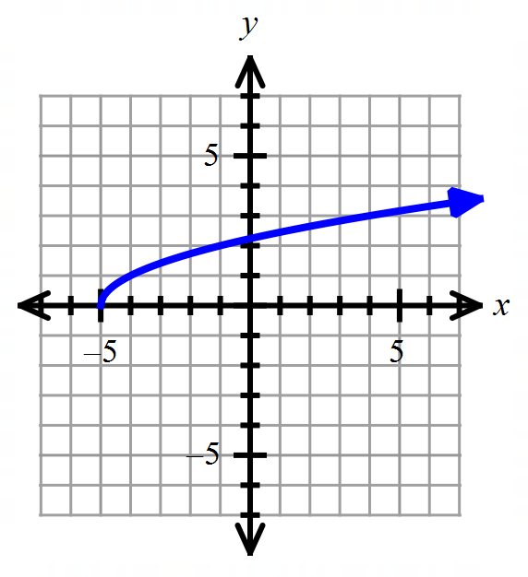

15) Use the graph of , as shown to the right, to draw the graph of

its inverse function.

16) Determine which two functions below are inverses of each other.

**Transformations of a Function**

Given , then has the following transformations on

* If , then there is a vertical stretch by a factor of
* If , then there is a vertical compression by a factor of

You can always use a table of values to help with a transformation!

* If , then there is a vertical reflection.
* Horizontal shift: units
* Vertical shift: units

**Parent Functions**

Students need to know the basic form of each parent function below.

**Quadratic Cubic Absolute Value Square Root**

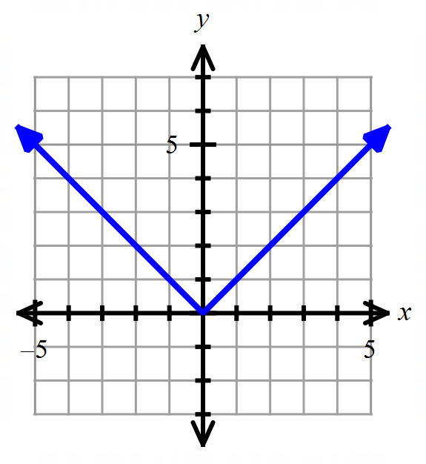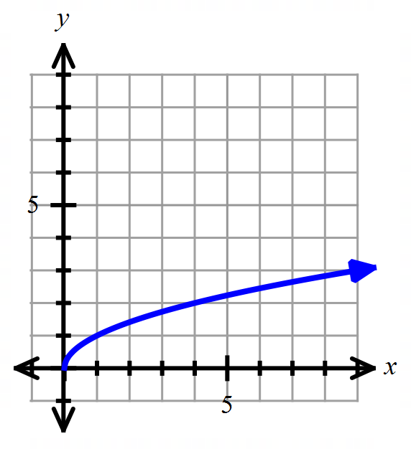

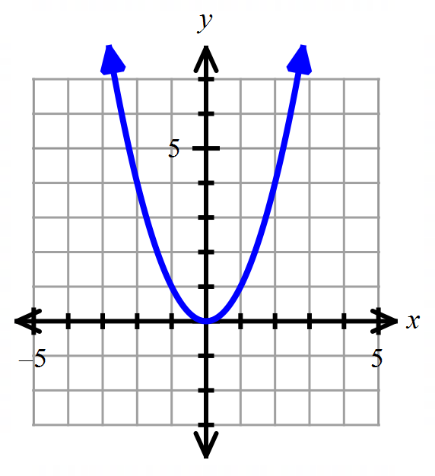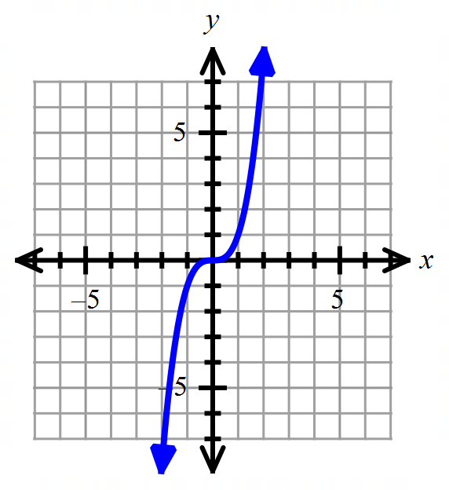

**Cube Root Exponential Logarithmic**

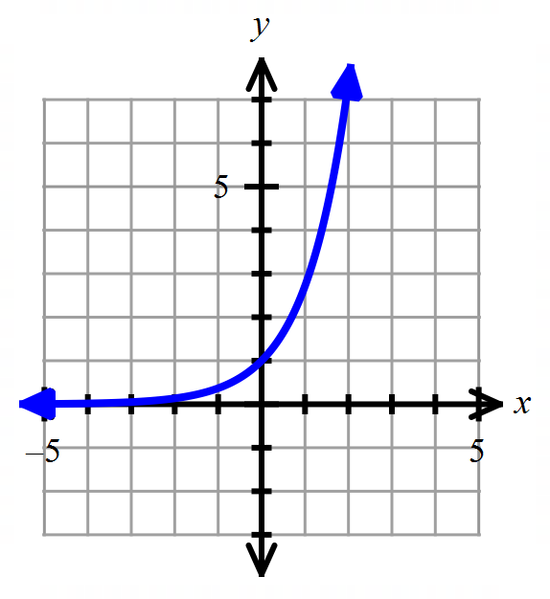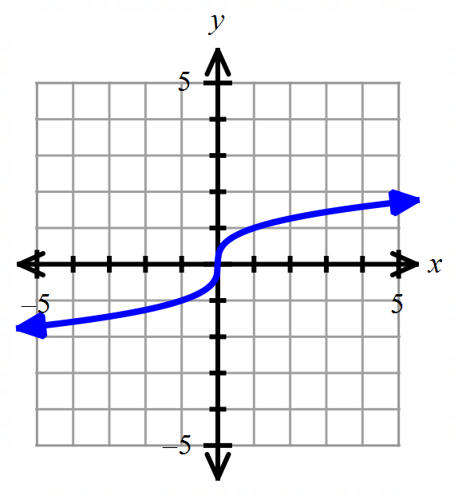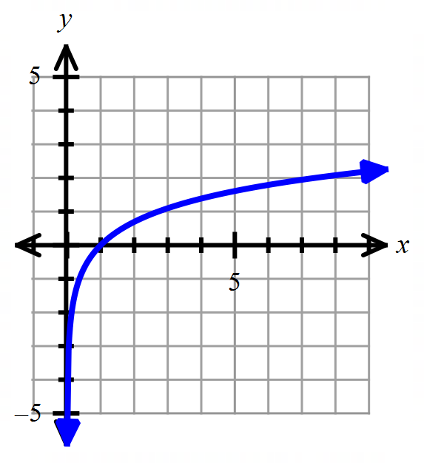

**For #17 – 18, sketch each parent function. Then use transformations to sketch**

17) Parent function: 18) Parent function: ;

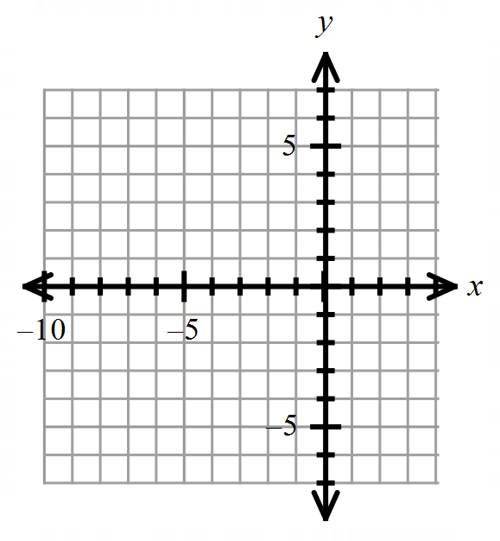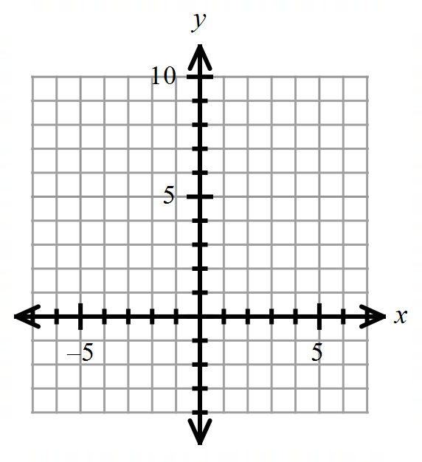

**For #19 – 20, use the given graph of to graph the described function on the same graph.**

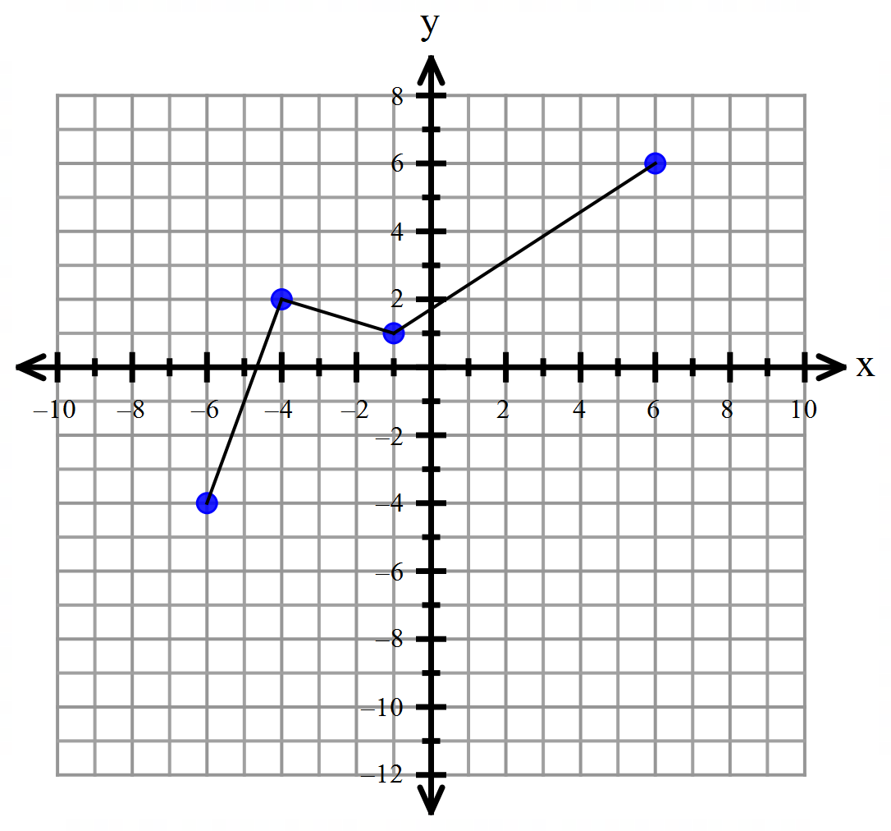 19) 20)

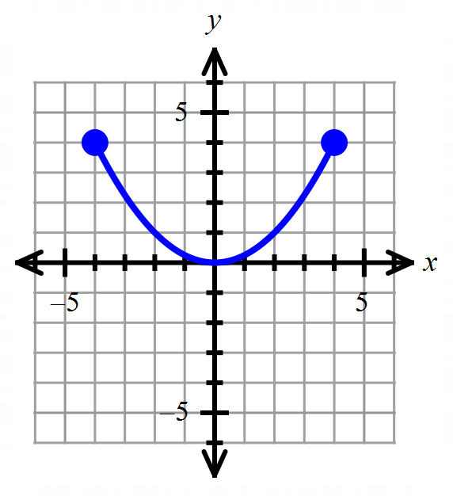

**For #21 – 25, determine if each relation is a function or not.**

21)

22) 23)

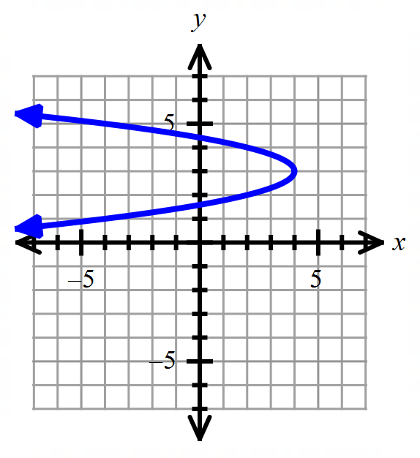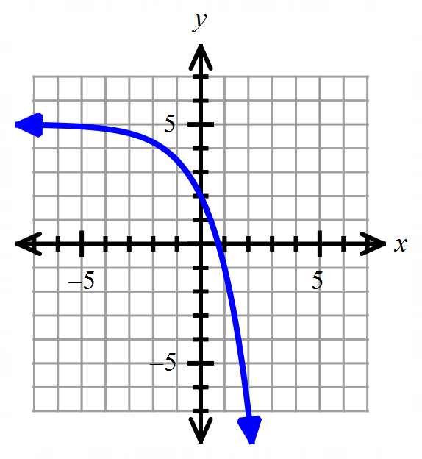

24) 25)