**Directions: A calculator is allowed on problems marked with asterisk* only. For those problems, round to 3 decimal places, as needed.**

**For #1 – 2:** John wants to measure the height of a tree. He walks exactly 100 feet from the base of the tree and looks up. The angle from the ground to the top of the tree is 33º.

*1) How tall is the tree?

*2) How far is the ground at John’s feet from the top of the tree?

*3) A man is in a boat that is floating 175 feet from the base of a 200-foot cliff. What is the angle of elevation (in degrees) from the man in the boat to the top of the cliff?

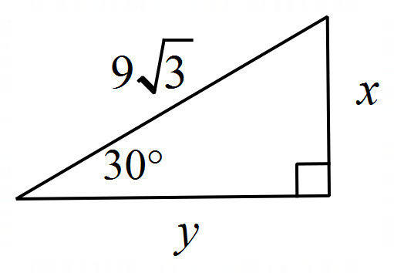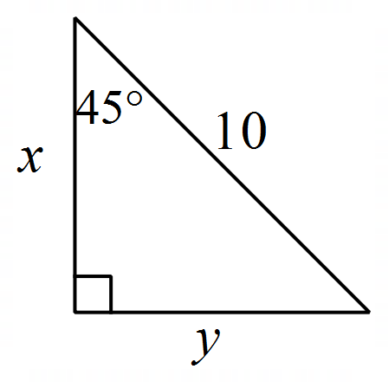**For #4 – 6: Solve for each variable and simplify the answers.**

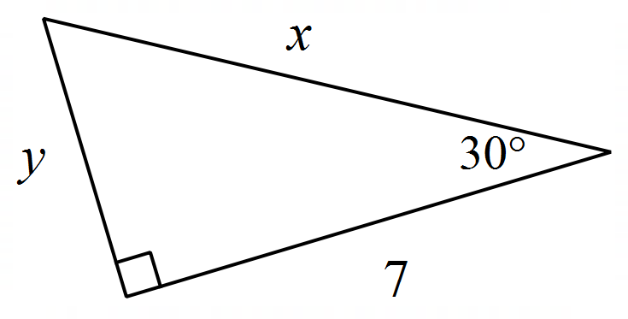4) 5) 6)

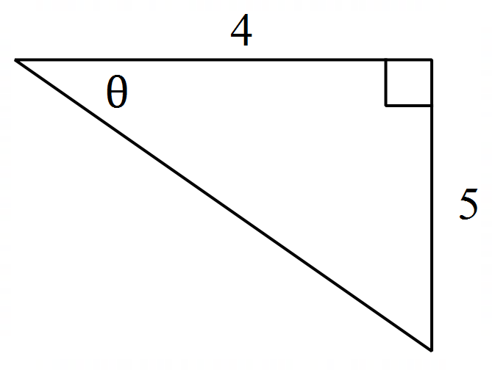**For #7 – 12: Use the diagram shown to find the requested trig ratios.**

**Simplify your answer.**

7) 8) 9)

10) 11) 12)

**For #13 – 16:** Find the reference angle for each given value of Write your answer in the same form as the given value (degrees or radians).

*13)  *14) *15) *16)

**For #17 – 20:** Find the exact value of each requested trigonometric functions, given that

17) 18) 19) 20)

**For #21 – 22:** Name the quadrant in which the angle lies.

21) Given 22) Given

**For #23 – 26:** Convert each value of from degrees to radians or from radians to degrees.

*23) *24) *25) *26)

**For #27 – 30:** Find a positive angle (less than 360° or that is coterminal with the given angle.

*27) *28) *29) *30)

**For #31 – 36: Matching each expression with an option that creates a true sentence. Not all options will be used, but do not use any option more than once.**

31) 32) **Find two true matches!** 33)

34) 35) 36)

**Options for #31 – 36 (not all will be used):**

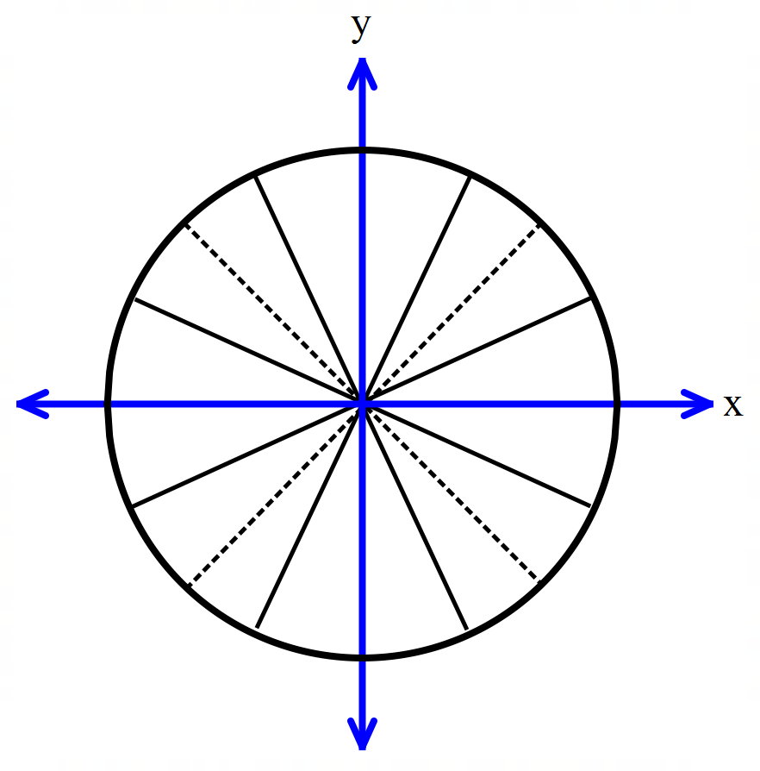**Student Workspace (optional). Feel free to fill in the unit circle below as a reference for future questions.**

**For #37 – 48, find each requested value, if it exists. Write “undefined” for values that do not exist.**

37) 38) 39) 40)

41) 42) 43) 44)

45) 46) 47) 48)

**For #49 – 52**: Find the value of within the given range of values for that would make each statement true. Write your answer in the same form as the given value of (degrees or radians).

*49) , *50) ,

*51) *52) ,

**Answers:**

1) 64.941 feet 2) 119.236 ft 3) 4)

5) 6) ; 7) 8)

9) 10) 11) 12)

13) 76 14) 15) 16)

17) 18) 19) 20)

21) II 22) III 23) 24)

25) 26) 27) 28)

29) 30) 31)

32) Two answers: 33) 34)

35) 36) 37) 38)

39) 40) 41) undefined 42) 0

43) 44) 45) 46) 0

47) 48) 49) 50)

51) 52)

**Make sure you have the unit circle memorized with both degrees and radians for this test.**

It is not possible to be successful on the Ch 4 Part I Test without knowing these values.