**Name: ______________________________**

***\*\*Do all work on your own paper and draw diagrams\*\****

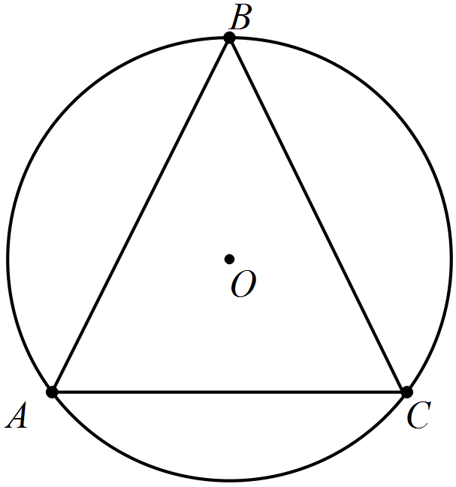1. ; Find . 2. Find *x.*



x°

78°



3. Chords are equidistant from the center of the circle. Find the measure of major arc ACB.

**For #4– 5: Use the diagram shown where AC = 6, AB = 12, CB = 13.**

4. Find the length of the radius of .

5. Which circle is the largest?

**For #6 – 7, use the diagram shown.**



190°

110°

A

6. Find the measure of

7. Find the measure of

**Use the diagram to the right for 8-9.**



C

8. are tangent to circle O at

A and B. PA = 40 and AO = 9. Find PB.

9. Find PC.

10. Find the diameter of a circle if an arc of the circle has a measure of 60 degrees and a length of 20 inches. Exact answers only (no decimals.)



C

D

11. If is a diameter, and *m* then solve for *x*.



12. Circle O is inscribed in .

PQ = 9, QR = 12, and PR = 14.

Find PT.

13. Find the length of a chord that is 6 cm from the center of a circle with a radius of 10 cm.

**For #14 – 16, refer to the diagram and the information given.**

*Given:*

14. Find 15. Find

16. Find .

17. A circle has a radius of 7 cm. Find the length of an arc with a measure of 80 degrees. Round your answer to the nearest hundredth of a cm.

**Answers:**

1) 2) 3) 4) 9.5 5) Circle B

6) 7) 8) 40 9) 32 10) 11) 10 12) 5.5

13) 16 cm 14) 15) 16) 17) 9.77 cm