**Formal Geometry:** **Chapter 6 Review** **Worksheet Name:____________________________________**

*For the entire worksheet: Round to 2 decimal places unless exact answers are specified.*

1. Which of the following statements are true? Choose all that apply.

A) A parallelogram with congruent diagonals is a rhombus.

B) A parallelogram with one right angle is a square.

C) A rhombus that is also a rectangle is a square.

D) A parallelogram with diagonals that bisect the angles is a rhombus.

**2.** The diagonals of a rhombus are 14 in and 48 in. Find the side length of the rhombus.

3. Find the value of each variable in the parallelogram shown below.

(*x*2 + 5*x*)o

(2*x*+ 28)o

(8*y*)o

**For #4, Find the value of *x* and *y* so that the quadrilateral is a parallelogram.**

4.

12

5. Find the diagonal of a square with a perimeter of 32 inches. Exact answer only.

6. Given the following vertices, determine whether quadrilateral BEFG is a parallelogram, rhombus, a rectangle, or a square. List all that apply. Show all evidence. B(1, 2), E(-2, -1), F(2, -5), G(5, -2)

[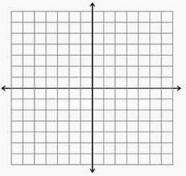](http://www.google.com/imgres?num=10&hl=en&tbo=d&biw=1280&bih=878&tbm=isch&tbnid=Khql0lrrMy_nDM:&imgrefurl=http://mathbits.com/MathBits/StudentResources/GraphPaper/GraphPaper.htm&docid=6RPEjJentpQNrM&imgurl=http://mathbits.com/MathBits/StudentResources/GraphPaper/14by14%20axes.jpg&w=302&h=285&ei=hcjVUNGfDbC-2AWv04HICw&zoom=1&iact=hc&vpx=108&vpy=155&dur=924&hovh=218&hovw=231&tx=143&ty=130&sig=110928772939558472342&page=1&tbnh=151&tbnw=160&start=0&ndsp=45&ved=1t:429,r:1,s:0,i:160)

7. If the diagonals of a rhombus are 24 and 10. Find the perimeter of the rhombus.

8. Find the perimeter of the rhombus. Exact answer.

12

60°

9) Find *x* and *y* from the rhombus below.

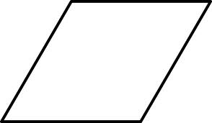

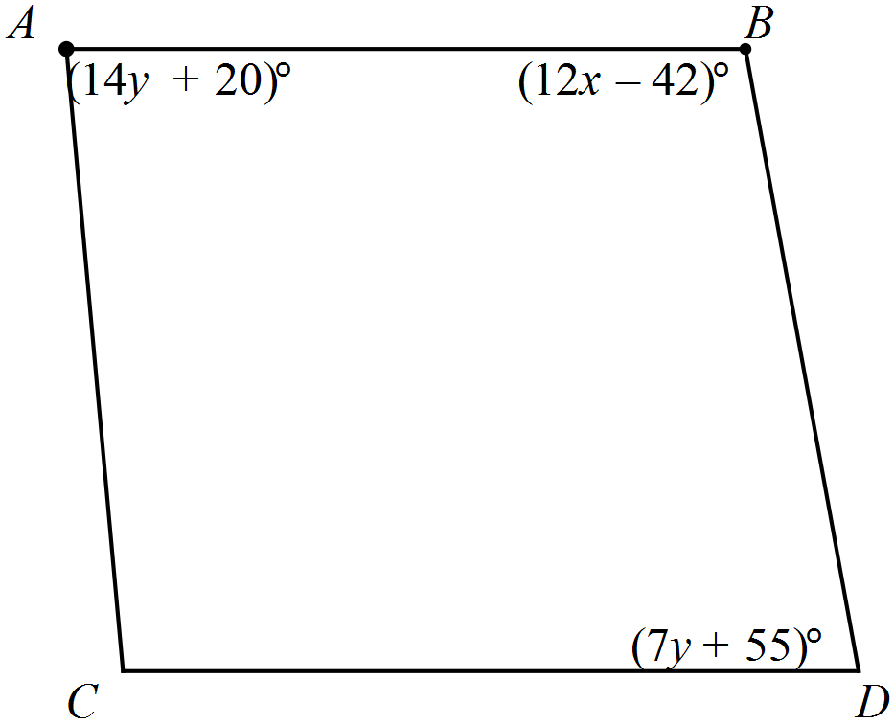 10) Find *x* and *y* if and ABCD is a parallelogram.

|  |  |  |  |
| --- | --- | --- | --- |
| 11**.** | is a rhombus. If then find the value of each requested measure. | | |
|  | a)  b) MK, to the nearest hundredth. |  |  |

|  |  |  |  |
| --- | --- | --- | --- |
| 12**.** | What is the measure of in Parallelogram , given the following: | | |
|  | **A.** |  |  |
| **B.** |  |
| **C.** |  |
| **D.** |  |

13. Garrett is trying to prove that quadrilateral ACDB is a parallelogram. Which of the following methods would be valid? Choose all that apply.

A) Show that both pairs of opposite angles are congruent.

B) Show that both pairs of opposite sides are congruent.

C) Show that the diagonals bisect each other.

D) Show that one pair of opposite sides is both parallel and congruent.

14. Find the length of the longest diagonal in a rhombus with a perimeter of 32 and one angle of 74 degrees.

15. Parallelogram ABCD has the following known vertices: A(-2, 5); B (-4, 1); C(1, 2). Find the coordinates of vertex D.

**For #16 – 19:** Is each statement always, sometimes, or never true?

16. If a quadrilateral has congruent diagonals, then it is a rectangle.

17. If a quadrilateral is a square, then it is a paralellogram.

18. If a quadrilateral is a rhombus, then its diagonals create 4 congruent isosceles triangles.

19. If a quadrilateral is a kite, then it’s diagonals are perpendicular.

20. Find the Perimeter of the kite.

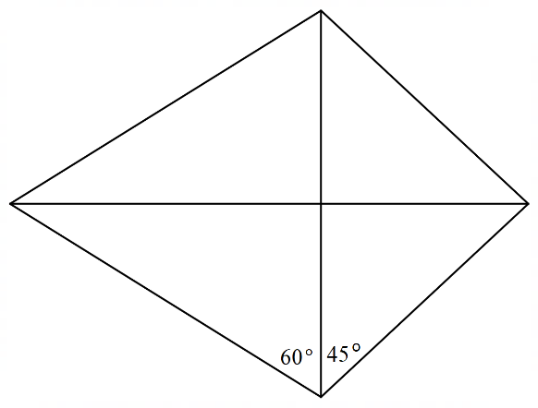

5

21. Given a trapeziod with a b1 = , b2 = , and m = , find m.

22. Find the area of the isosceles trapezoid.

Chapter 6 Review Key:

1. 2. 25 in 3. *x* = 4 or -7,  *y* = 18 or 20.75 4. *x* =2, *y* = 2 5.

6. Parallelogram, Rectangle, (plus evidence of both) 7. 52 8.

9. x = 7, y = 11 10. x = 11 and y = 5 11a) 11b) 12. B

13. A, B, C, and D 14. 12.78 15. D (3, 6) #16 – 19: Answers will be given in class.

20. 21. 40 cm 22.