Renee Gates

Social Studies Department Lead & Yearbook Teacher

Hi, my name is Renee Gates and I will be teaching 7th grade Social Studies and run the class that creates our very first yearbook! This is my 13th year teaching and my 3rd here in Washoe County. I grew up in Grass Valley, CA and attended UNR/Nevada. From the second I stepped on campus I knew I wanted to be part of the Wolf Pack. It was the only college I applied to because I fell so in love with the campus. After graduation, my college sweetheart and I moved to the Central Valley of California in search of jobs. We spent 10 years working and living between the cities of Modesto, Manteca, Stockton, and Linden. After some deep soul searching for what makes us happy, we decided to set sail back for Reno in 2017 and we are constantly in awe of how much happier we are living up here.

In my 13 years of education I have earned my master’s in educational leadership and have had the opportunity to be a summer school principal. When we lived in CA, I was a 6th, 7th, & 8th grade ELA & Social Studies teacher at a K-8 and I also created the yearbook. When we moved back to Reno, I taught at Hug High School for 2 years teaching SEL, World, & U.S. History. This past year I was an ELA teacher at Depoali. All these experiences have led me to become a MHMS Falcon with the rest of you and I am so excited.

John and I were married on International Talk Like a Pirate Day, which is 9/19- so we love all things pirate. We have 2 sons, William (7) and David (5) who often dress in pirate attire! A few years ago we went on a Disney Cruise and dressing up for pirate night as a family was a definite highlight.

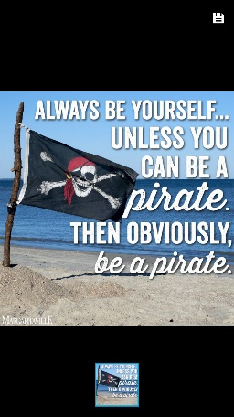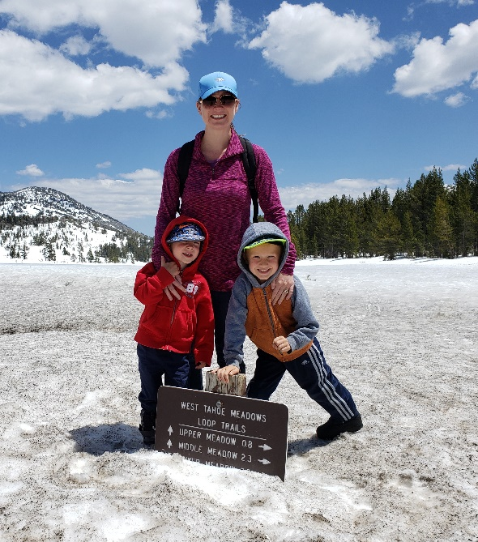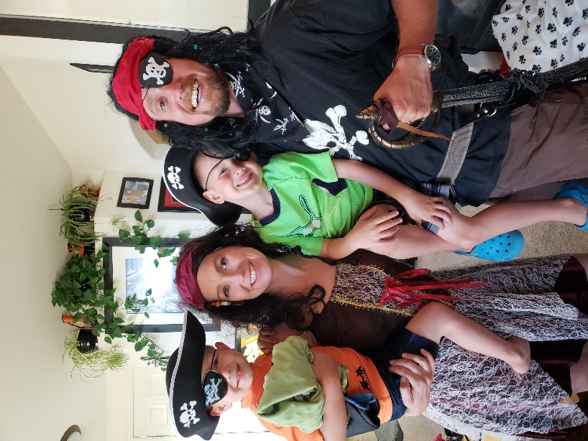I enjoy all adventures outdoors including going scuba diving, sky diving, and skiing/snowboarding when time and money permit. I have a unique talent for making a short story long, so be forewarned. I apologize in advance and you’re welcome 😊. If you ever have a few extra minutes, ask me about my 1 and only marathon that I ran in college where I accidentally ate a dollop of Vaseline around mile 15, or that epic field trip I took students on where we rode the BART into San Francisco and got lost for a bit trying to make it to the Alcatraz Ferry. Good times.

***Favorites:***

**Color:** Purple

**Book:** Where the Red Fern Grows

**Movie:** You Got Mail

**Season:** Winter

**Insect:** Butterfly

**Bird:** I love reading about all raptor birds, especially the bald eagle and now falcons even more than before!

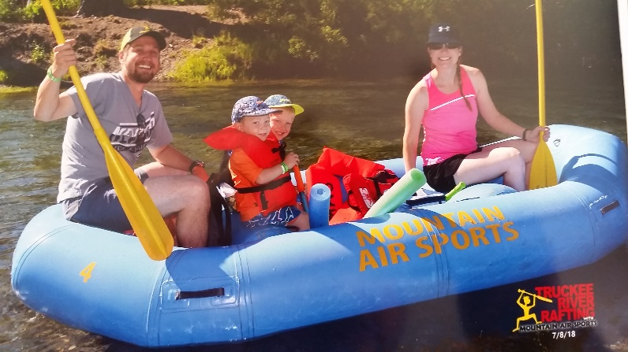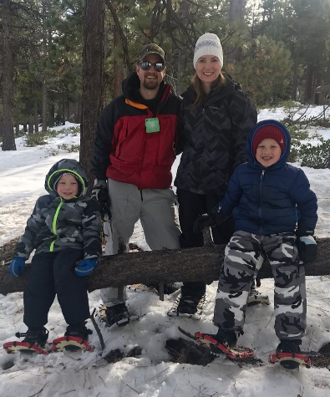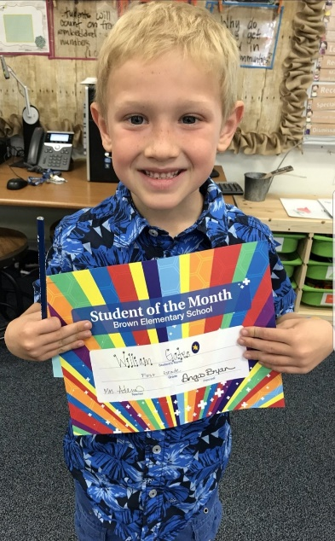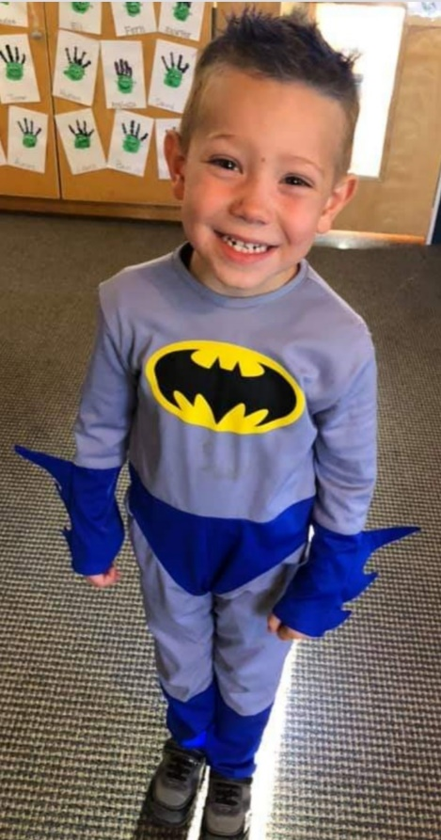**Sports Teams**: Bay Area Region: 49ers, Giants, A’s, and now the Las Vegas Raiders & Golden Knights.

Also, local teams the Wolf Pack & Reno Aces.