**4.5 Notes: Graphs of Sine and Cosine Functions**

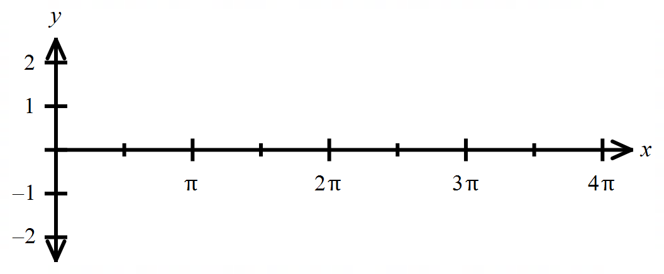**Exploration:** For each trig function below, find the requested values. Then sketch a graph of the function

|  |  |  |  |  |  |  |  |  |  |
| --- | --- | --- | --- | --- | --- | --- | --- | --- | --- |
|  |  |  |  |  |  |  |  |  |  |
|  |  |  |  |  |  |  |  |  |  |

* 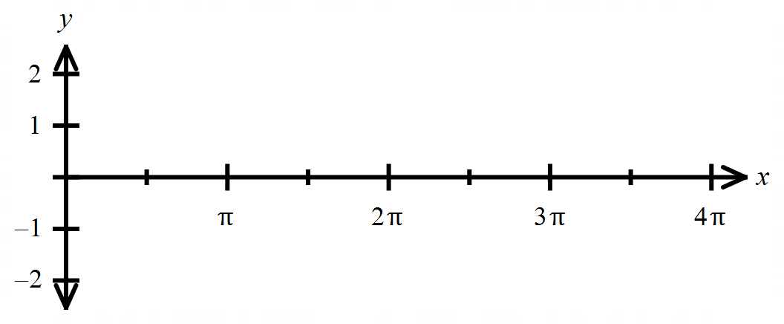

|  |  |  |  |  |  |  |  |  |  |
| --- | --- | --- | --- | --- | --- | --- | --- | --- | --- |
|  |  |  |  |  |  |  |  |  |  |
|  |  |  |  |  |  |  |  |  |  |

|  |  |
| --- | --- |
| **The Sine Function** | |
| Parent function | **Amplitude**   * Distance from the midline to the maximum or minimum * Amplitude from parent function:   **Period**   * Horizontal distance for when the function “repeats” its shape. * Period for parent function: |
| **Transformations of the sine function** | **Amplitude**   * If , there is a vertical stretch. * If , there is a vertical compression.   Note: If , there is a vertical reflection.  **horizontal stretch or compression**   * Changes the period of the function * Period =   **horizontal shift (translation right or left)**   * Phase shift: moves the start/end of the period units   **vertical shift (translation up or down)**   * Moves the midline up or down units |

**For Examples 1 – 2:** Find the requested information, and then graph both the parent function and on the provided coordinate system. Use a dotted (dashed) curve for the parent function.

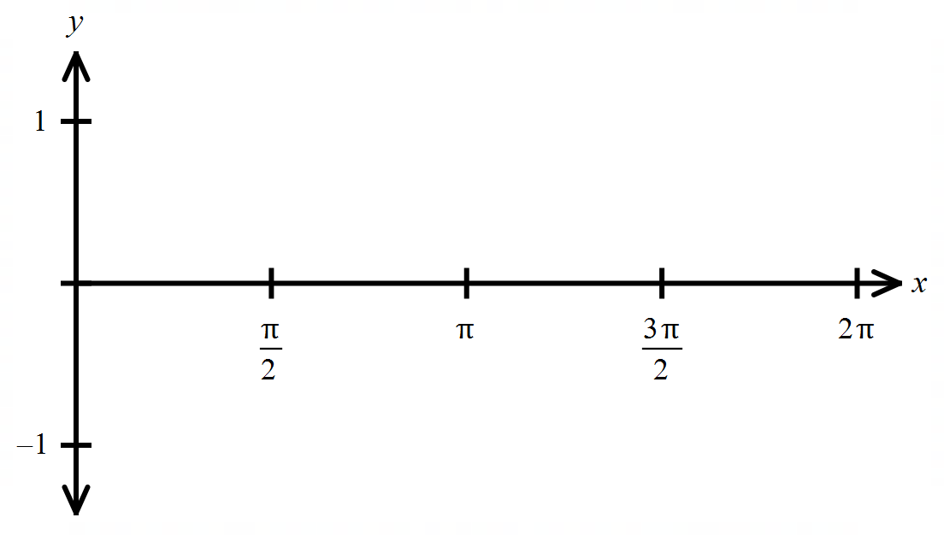

1)



* + Amplitude
  + Period

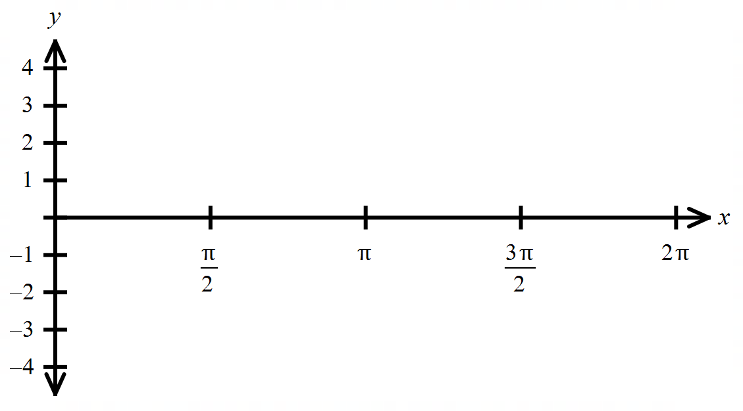

2)

* + Amplitude
  + Period
  + Shift (translation)

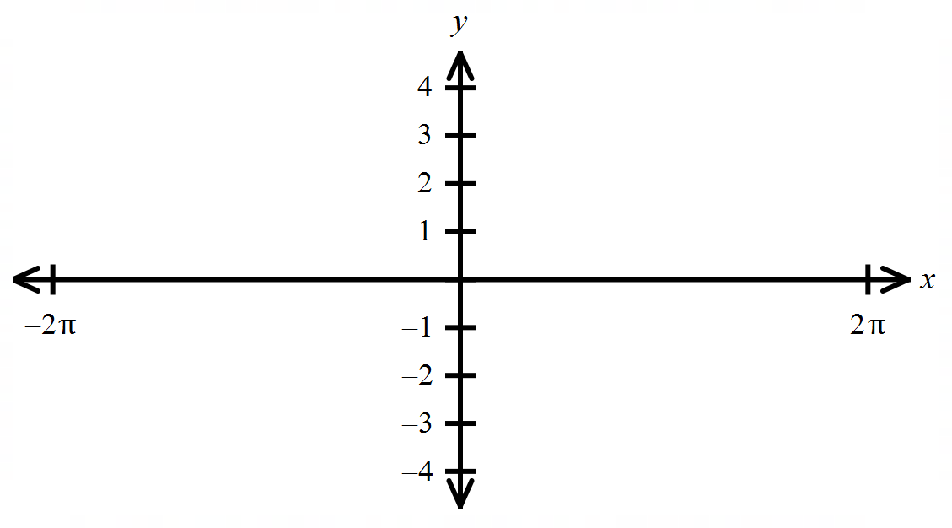**Example 3:** Find the requested information below for Then graph one period of the function.

* Amplitude
* Period
* Phase Shift

|  |  |
| --- | --- |
| **The Cosine Function** | |
| Parent function | **Amplitude**   * Amplitude from parent function:   **Period**   * Period for parent function: |
| **Transformations of the Cosine function** | have the same behaviors with the cosine function as they do with the sine function. |

**For examples 4 – 5:** Find the requested information, and then graph the function on the given interval.

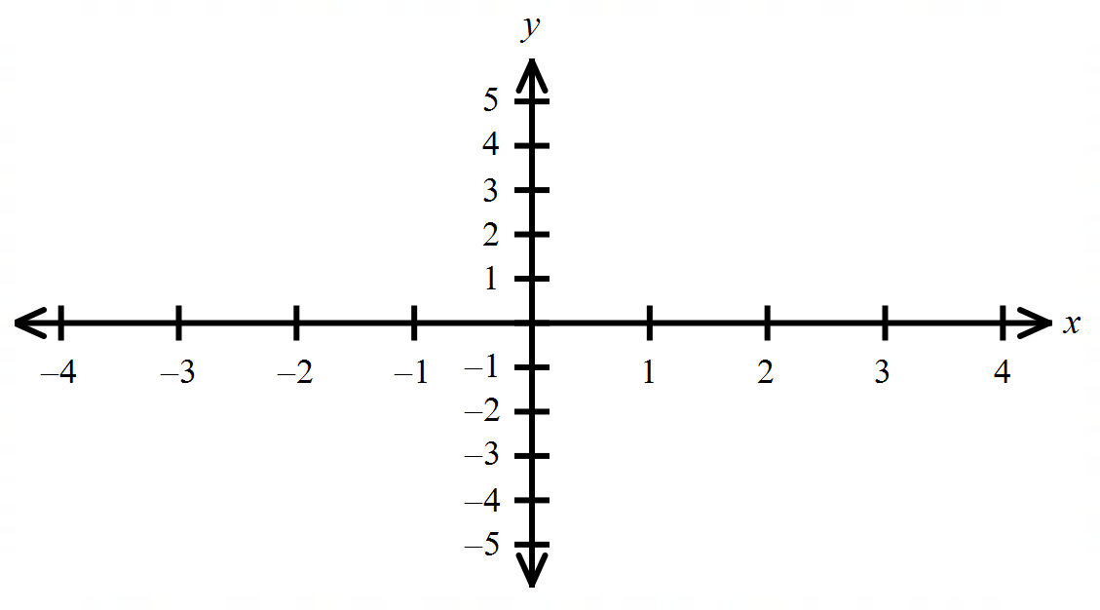

4) Graph the function for .

* + Amplitude
  + Period
  + Shifts (translations)

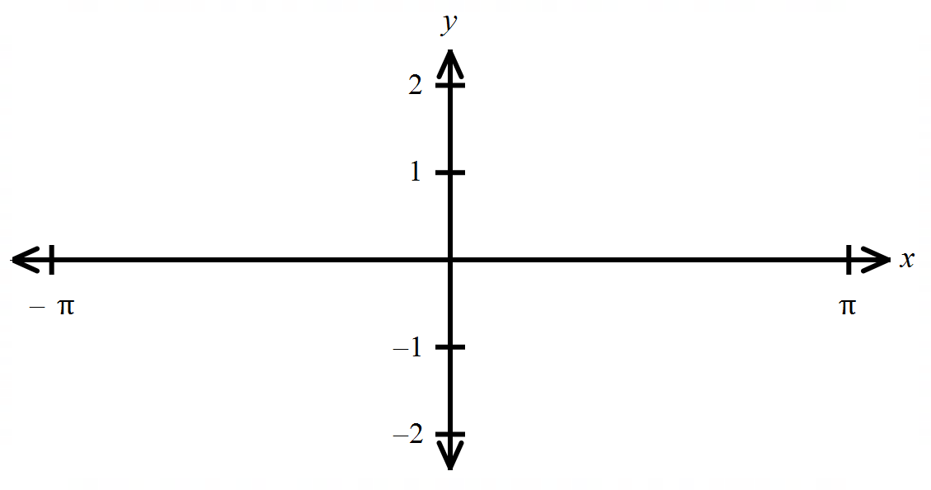

5) . Graph one period of the function.

* + Amplitude
  + Period
  + Phase Shift

**For #6 – 7:** Given that

6) Which statements are true for Select all that apply.

1. There is a phase shift of units to the left.
2. There is a vertical shift up one unit.
3. The period is
4. The period is
5. The maximum height of is
6. The minimum height of is

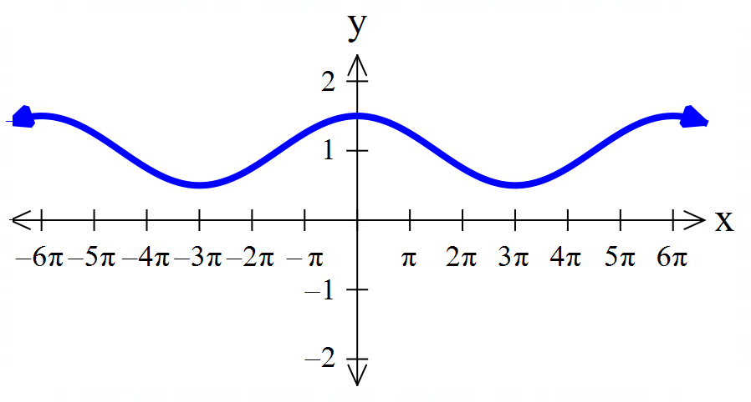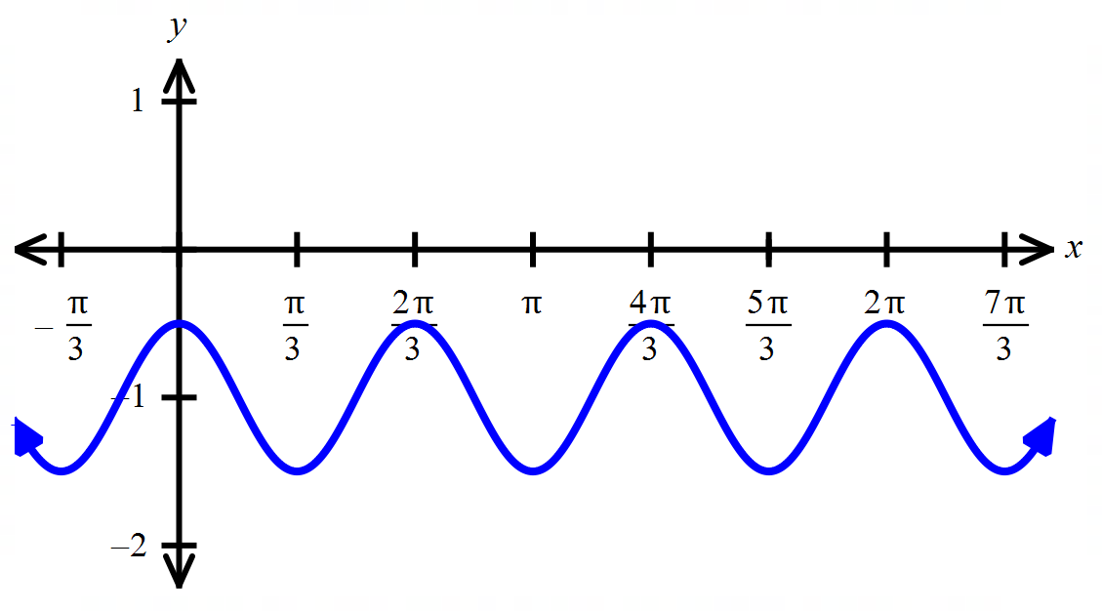 7) Which is the correct graph of

A) B)

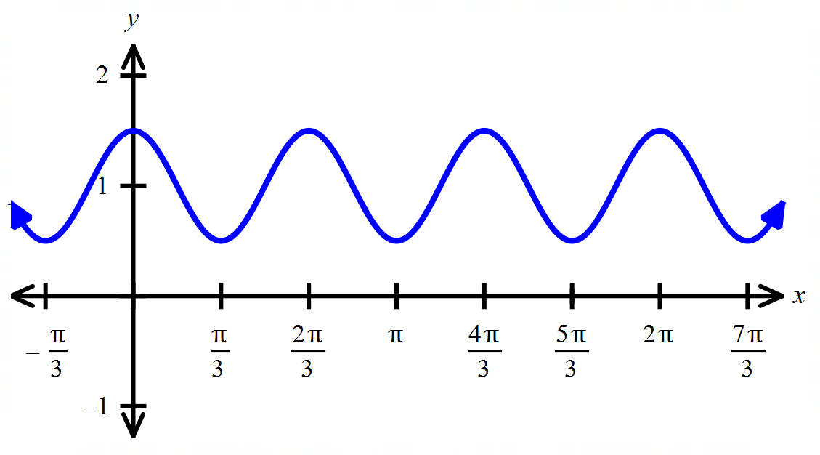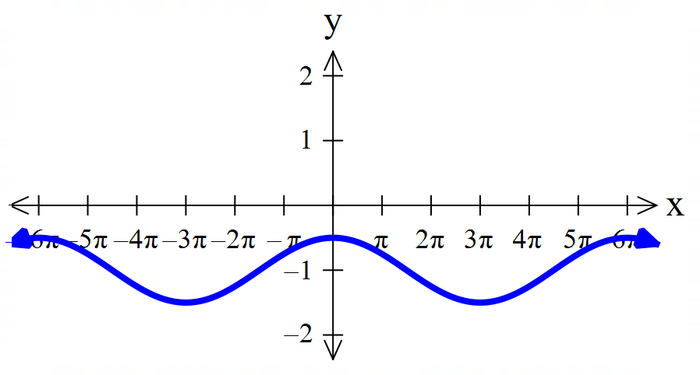

C) D)

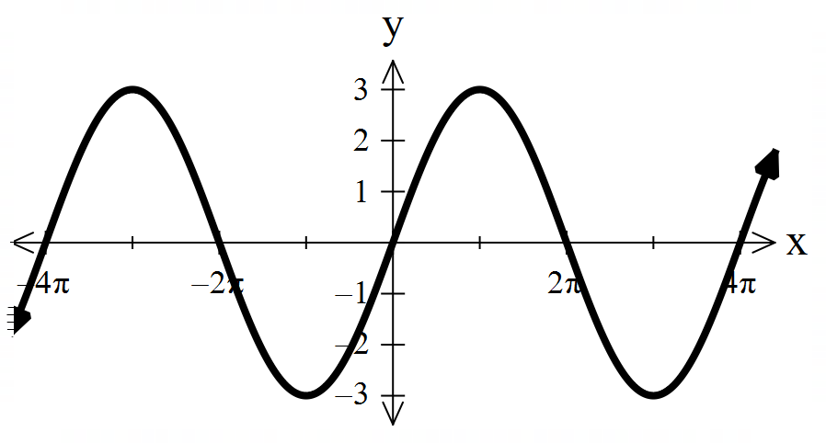**For #8 – 9: Multiple Choice.**

8) Which of the following could be the equation of the function?



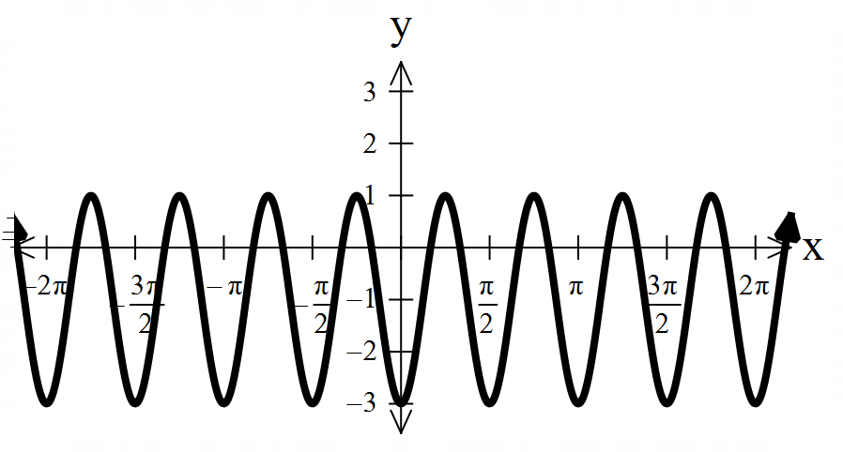

9) Which of the following could be the equation of the function?



10) Write at least one equation for the function shown below. There is more than one correct answer!

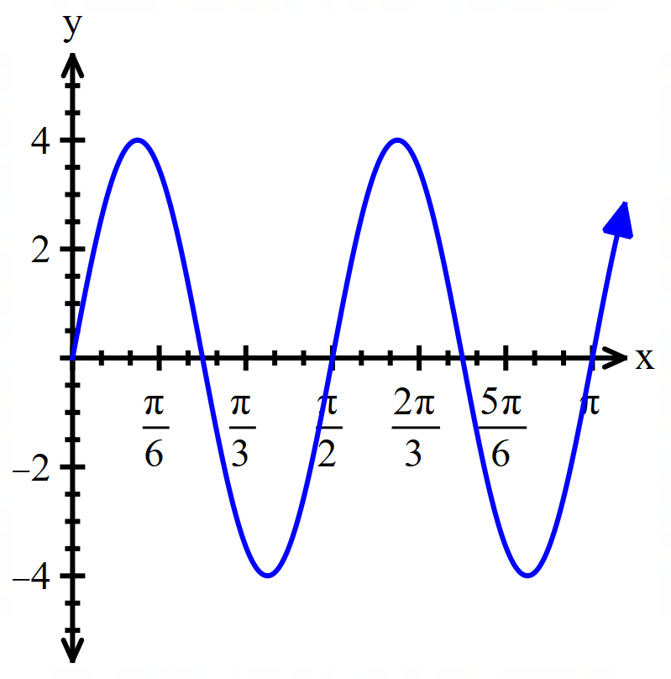



**4.6 Notes: Graphs of Other Trig Functions**

**Exploration:** For each trig function below, find the requested values. Then sketch a graph of the function

|  |  |  |  |  |  |  |  |  |  |  |  |
| --- | --- | --- | --- | --- | --- | --- | --- | --- | --- | --- | --- |
|  |  |  |  |  |  |  |  |  |  |  |  |
|  |  |  |  |  |  |  |  |  |  |  |  |



Reminder:

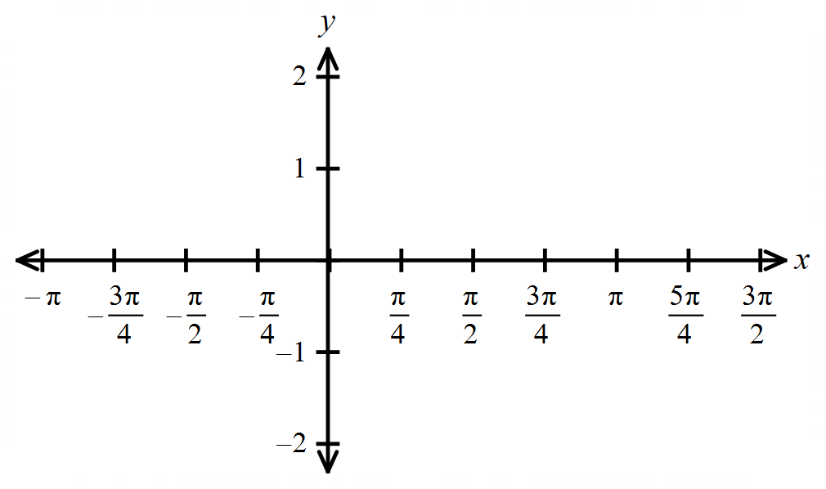



|  |  |  |  |  |  |  |  |  |  |  |  |
| --- | --- | --- | --- | --- | --- | --- | --- | --- | --- | --- | --- |
|  |  |  |  |  |  |  |  |  |  |  |  |
|  |  |  |  |  |  |  |  |  |  |  |  |

Reminder:



**Reflection:** Why are the vertical asymptotes for each of these trig functions located in those specific places?



|  |  |
| --- | --- |
| **The Tangent Function** | |
| Parent function | **Vertical Asymptotes**   * VA for parent function:   **Period**   * Period for parent function: |
| **Transformations of the Tangent function** | **A:** vertical stretch or compression   * A multiplies the height of the curve * If , then the curve has a vertical reflection     **B:** horizontal stretch or compression   * changes the period * Period of tangent:   **C:** horizontal shift (translation left or right)   * Phase shift =   **D:** vertical shift (translation up or down)   * The midline is moved up or down units. |

**Examples 1:** Graph for

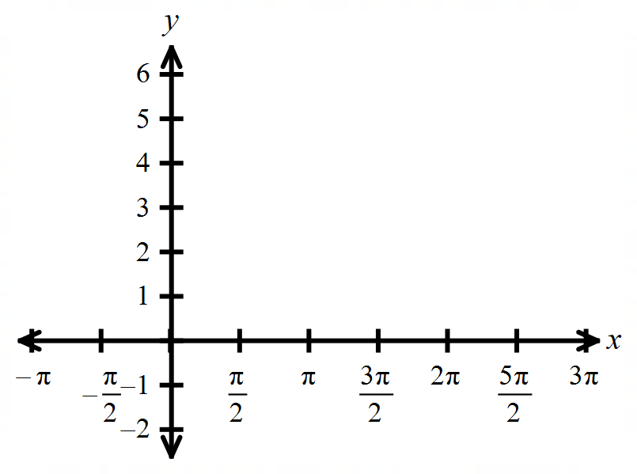 Hint: Where is this function undefined?



|  |  |
| --- | --- |
| **The Cotangent Function** | |
| Parent function | **Vertical Asymptotes**   * VA for parent function:   **Period**   * Period for parent function: |
| **Transformations of the Cotangent function** | have the same behaviors with the cosine function as they do with the sine function. |

**Example 2:** Graph on the provided coordinate system.

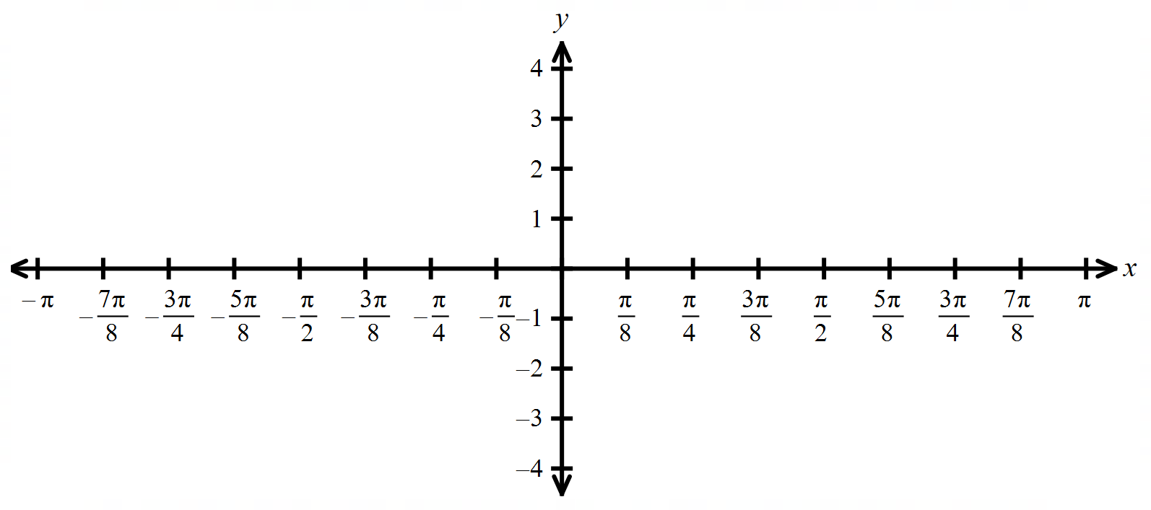

**E**



Y = A sec (Bx – C) + D

A = Location of the vertices of the parabola

B = Change in the period: P =

C = Phase shift: P.S. = (left or right)

D = moves midline up or down

Y = csc x (reciprocal of sin)

Y = A csc (Bx – C) + D

A = Location of the vertices of the parabola

B = Change in the period: P =

C = Phase shift: P.S. = (left or right)

D = moves midline up or down

Graph y = 3 cot (2x – π) -2

Graph y = -3 sec -1 for –π < x < 5π

**4.7 Notes: Inverse Trig Functions**

Sin-1: inverse of the restricted sine function y=sin x, .

Y = sin-1 x means sin y= x

This does not mean

The horizontal line test tells us whether the function has an inverse or not.

One way to graph Y = sin-1 x is to take points on the graph of the restricted sine function and reverse the order of the coordinates.

Another way to graph Y = sin-1 x is to reflect the graph of the restricted sine function about the line y = x.

For inverse trig functions, there is a restriction on the range

() ()

() ()

() ()

Find the exact value of sin-1

Find the exact value of sin-1

Find the exact value of cos-1

Find the exact value of tan-1 )

Find the exact values if possible

cos(cos-1 0.7)

sin (sin-1 π)

cos (tan-1 )

sin ( tan-1 )

If 0 < x ≤ 1, write cos( sin-1 x) as an algebraic expression.

If x > 0, write sec(tan-1 x) as an algebraic expression.

**4.8 Notes: Applications of Trig Functions**

1) A guy wire is 13.8 yards long and is attached from the ground to a pole 6.7 yards above the ground. Find the angle, to the nearest tenth of a degree that the wire makes with the ground.

2) You are taking your first hot-air balloon ride. Your friend is standing on level ground, 100 ft away from your point of launch, making a video of the terrified look on your rapidly ascending face. How rapidly? At one instant, the angle of elevation from the video camera to your face is 31.7o. One minute later, the angle of elevation is 76.2o. How far did you travel to the nearest tenth of a foot, during that minute?

3) You are standing on level ground 800 ft from mt. Rushmore looking at the sculpture of Abraham Lincoln’s face. The angle of elevation to the bottom of the sculpture is 32o and the angle of elevation to the top is 35o. Find the height of the sculpture of Lincoln’s face to the nearest tenth of a foot.

4) 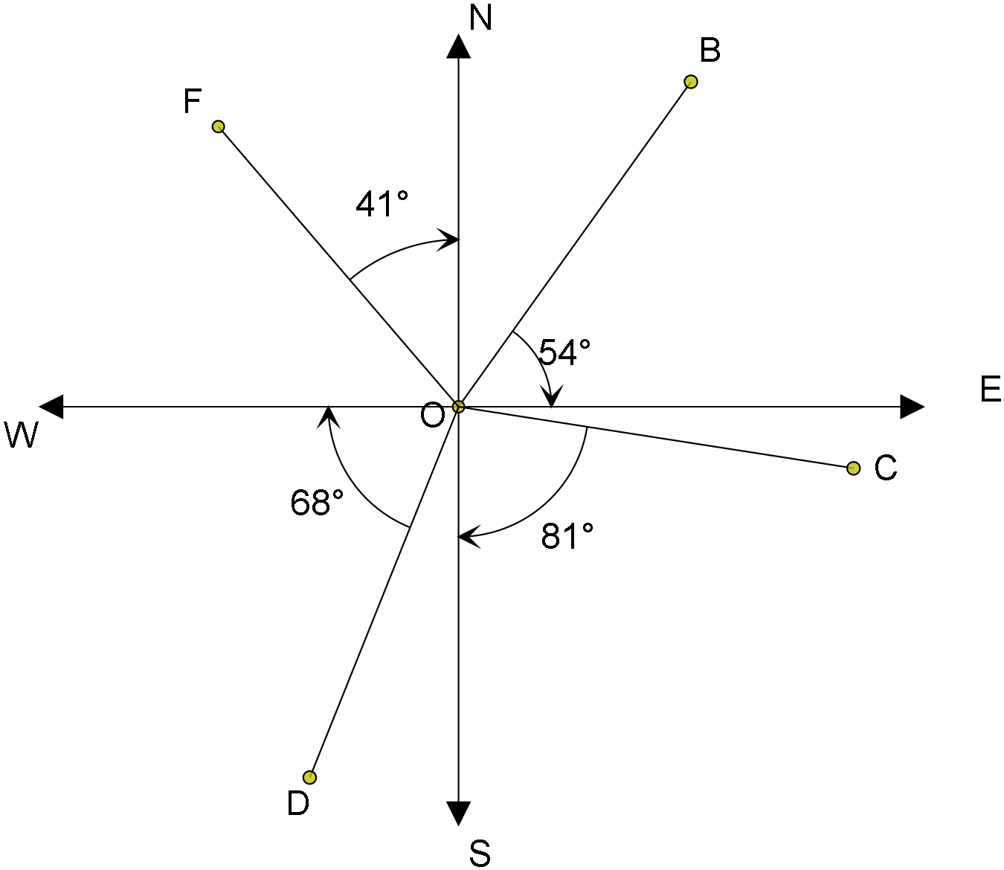Find the bearing from O to B

5) Find the bearing from O to F

6) Find the bearing from O to D

7) You leave the entrance to a system of hiking trails and hike 2.3 miles on a bearing of S 31o W. Then the trail turns 90o clockwise and you hike 3.5 miles on a bearing of N 59o W.

a) How far are you from the entrance?

b) What is your bearing from the entrance?

Simple Harmonic Motion

d = a cos t or d = a sin t

amplitude

period of the motion is where >0

frequency f = where

also, f =

8) A ball on a spring is pulled 4 inches below its rest position and then released. The period of the motion is 6 seconds. Write the equation for the balls simple harmonic motion.

9) A weight is attached to a spring is pulled down 6 inches below the equilibrium position. Assuming that the frequency of the system is cycles per second, determine a trig model that gives the position of the weight at time t seconds.