**Name:__________________________**

**In problems # 1 – 6, solve for the variable(s).**

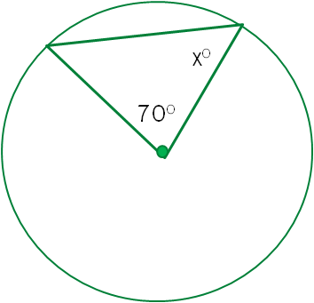

***x*o**

1. 2.



3. 4.



*x*

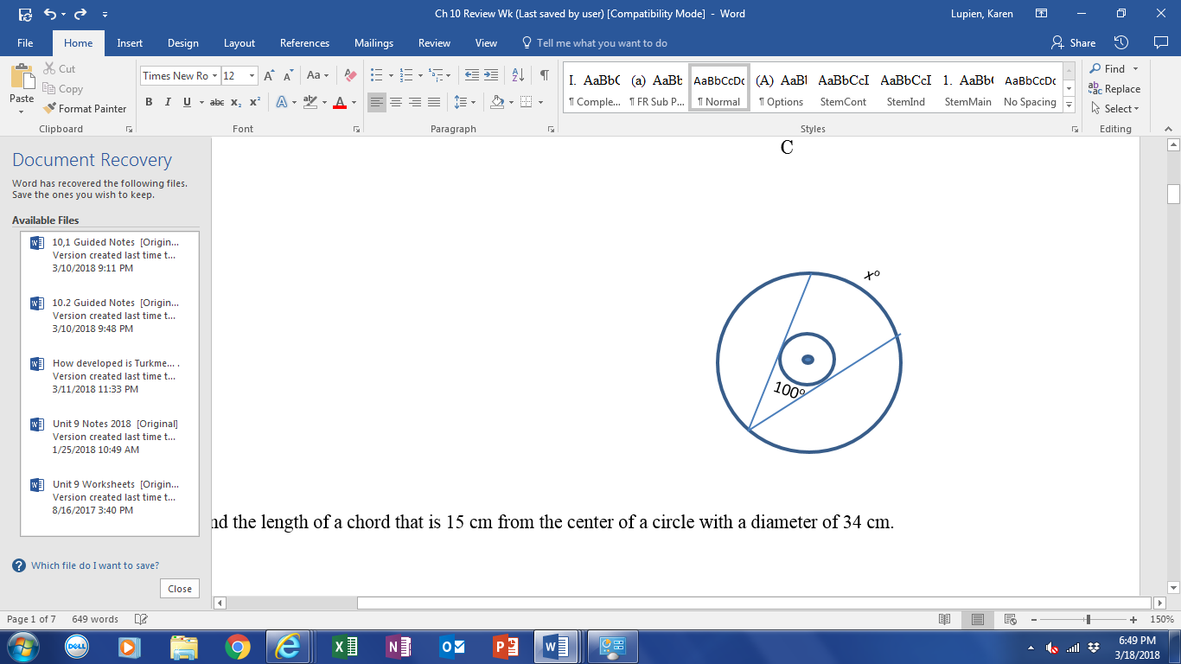

5.

6. Find the length of a chord that is 15 cm from the center of a circle with a diameter of 34 cm.



7. are tangent to circle O at

A and B. PA = 40 and PO = 41. Find PB and the radius of the circle.

8. A square with an area of 100 in2 is circumscribed about a circle. Find the exact circumference of the circle.

9. A 16 by 12 rectangle is inscribed in a circle. Find the radius of the circle.

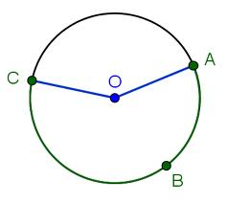

10. Find the length of arc AC if AOC = 110 and the diameter of the circle is 12 m.

Round your answer to the nearest hundredth of a meter.

11.) Points X and Y are two different points on a circle. Point M is located so that length XM=YM. Which of the following could be true.

(A) I only

(B) II only

(C) I and II only

(D) II and III only

(E) I, II, III

I. M is the center of the circle

II. M is on arc XY

III. M is outside of the circle

12. Find the area of the shaded region if the length of the arc along the shaded region is cm. Exact answers only.

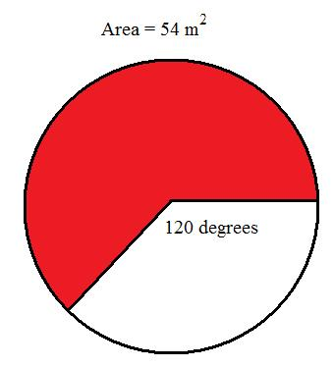

13. Given Tangent circles A, B, C, with AB=9, BC = 14, AC = 11. Find the radii of the 3 circles.



14. Use circle *O*. Given , 15. ,

what is ?



*P*

*R*

*T*

*Q*

*O*

82°

16. In circle *N*, *m* arc JM = (6*x* + 5)o, *m* arc KL = (10*x* + 3)o, and . Find *x*.

*H*

*L*

*M*

*K*

*N*

*J*

17. Two tangents are drawn from point *D* to circle *A*.

*D*

*A*

*C*

*B*

What conclusion is guaranteed by this diagram?

* 1. *AD* = *BD*
  2. *AC* = *DC*
  3.  is a right triangle.

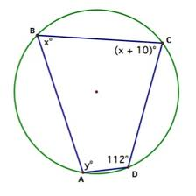

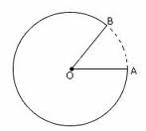18. Find *x* and *y.* 19. The dotted arc has a length of 4.2 in. Find the radius of the circle to the nearest hundredth, if BOA = 35o.



*x*o

20. Find *x*.

21. Find the measure of arc AB if P = 62 and the measure of arc AC = 151.

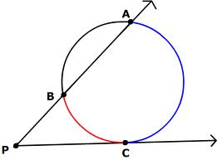

22. A child’s bicycle tire travels a distance of 450 inches after eight rotations of the tire. Find the area of the circular surface of the tire, rounded to the nearest square inch.

23. Find the area of the shaded region if the circumference of the circle is cm (exact answer only.)

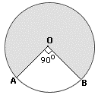



10

24. Find the area of segment in the diagram to the right.

Exact answer only.

25. Given that Find the measure of major arc .

**In problems #26 – 29, solve for the variable. Simplify any radical answers.**



10

y

26. 27.



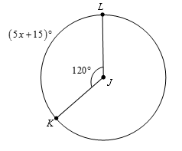28. 29.

30) A circular spinner is divided into 12 equal sections. If the area of one sector is 28 , then find the length of the curved outer portion of one section, rounded to the nearest tenth of a cm.

**Answers**

1) 70 2) 55 3) 2 4) 18 5) 160

6) 16 cm 7) 40, 9 8) 10 inches 9) 10 cm

10) 11.52 m 11) answer not given ☺ 12) 13) Circle A: 3; Circle B: 6; Circle C: 8

14) 82 15) 115 16) 17 17) D 18) *x* = 68; *y* = 102

19) 6.88 in 20) 32 21) 182 22) 23) 24)

25) 280 degrees 26) 3 27) 28) 21 29) 16 30) 5.4 cm