**Formal Geometry Name:______________________________**

**Ch 11 Review Worksheet**

**Use exact answers for all problems, unless otherwise indicated**.

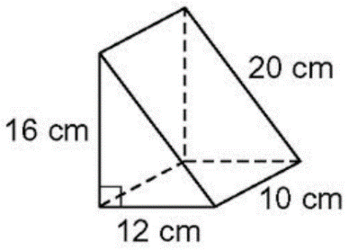1) Find the volume. 2) Find the volume of the square pyramid shown, if the perimeter of the base is 24 in.

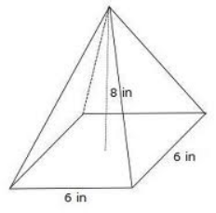

**For #3 – 4:**  A basketball is shown below. Find the following, in terms of *x* and pi, if the radius of the basketball is represented by 6*x*.

[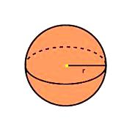](http://www.google.com/imgres?q=sphere+volume&hl=en&gbv=2&biw=1024&bih=591&tbm=isch&tbnid=UUJlNkVz4I2QiM:&imgrefurl=http://www.bbc.co.uk/scotland/learning/bitesize/standard/maths_ii/measure/volume_comp_solids_rev1.shtml&docid=GTrg2rCQ0--bnM&imgurl=http://www.bbc.co.uk/scotland/learning/bitesize/standard/maths_ii/images/sphere_with_radius.gif&w=226&h=226&ei=ynBCT5j7GefSiALX14GGAQ&zoom=1)

3) Surface Area

4) Volume

5)A container for mixing cement is shaped like a rectangular prism with a length of 60 inches, a width of 48 inches, and a height of 32 inches. The container can be safely filled within 2 inches of the top. Nicole makes enough cement to fill the container one time in order to fulfill an order for 48 *cubic feet* of cement. How many cubic feet of cement will she have left after filling the order?

6) Find the radius of a sphere whose volume is 420 m3. Round to the nearest tenth.

7) A sphere has a volume of 972 ft3. Find the radius.

8) A paperweight is made of pure iron and is in the shape of a cone. The cone has diameter of 4 cm and is 6 cm tall.

If the iron costs $3.50 per gram, how much is the paperweight worth? Hint: iron weighs approximately 7.8 grams per cubic centimeter.

9) If two similar solids have ratio of volumes of 16 : 54, and the surface area of the larger solid is 108π in², find the surface area of the smaller solid.

10) Find the SA of the cone shown, in terms of pi.

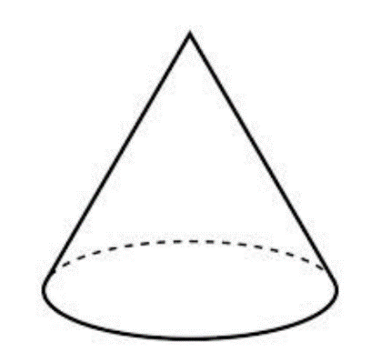

6 mm

8

mm

11) Find the V of the cone from #10, in terms of pi.

12. What is the ratio of the volumes of two cubes with edges of lengths 4 inches and 8 inches?

**A**.

**B**.

**C**.

**D**.

13. Two similar cones have radii of 3 cm and 8 cm. Find the ratio of their volumes, small to large.

14. A sphere is inscribed inside a cube with a volume of 64 cm3. Find the surface area of the sphere.

15. A paperweight is made of pure silver in the shape of a cylinder. The cylinder has diameter of 6 cm and is 10 cm tall. If the silver weighs 10.5 grams per cubic centimeter, to the nearest hundredth of a gram, how much does the paperweight weigh?

**For #16 – 18:** Convert between ratios

A manufacturer is designing two geometrically similar cylinders to be made out of plastic and painted. She will need to have surface area calculations for how much paint is needed to cover the outside; she also needs a volume calculation know how much plastic to order.

The height of the green cylinder is 7 centimeters. The height of the blue cylinder is 10 centimeters.

16. What is the ratio of surface areas (small to large)?

17. What is the ratio of volumes (small to large?)

18. If the blue cylinder has a volume of 36 cubic centimeters, what is the volume of the green cylinder?

Retain every digit of the decimal.

19. The volume of a sphere is inches cubed. What is its radius?

**Answers:**

1) cm3 2) 96 in3 3) 2 units2 4) 3 units3 5) 2 6) 7) 9 feet

8) $686.12 9) in2 10) SA = 96 11)

12) A 13) 27: 512 14) 16 cm2 15) 2968.81 grams 16) 49:100 17) 343:1000

18) 12.348 cubic centimeters 19) 5 inches