

SUN VALLEY ELEMENTARY SCHOOL

Family/Student Handbook

2025-2026

5490 Leon Drive

Sun Valley, NV 89433

Phone: (775) 674-4420

[www.washoeschools.net/SunValley](http://www.washoeschools.net/SunValley)

[www.facebook.com/SunValleyLionPride](http://www.facebook.com/SunValleyLionPride)

Table of Contents

###### **Introduction Section**

*Letter from the Principal* pg. 3

*Staff List* pg. 4

Identification Section

Statement of Purpose & Mission Statement pg. 5

Procedures Section

WCSD 2025-2026 Calendar pg. 6

Sun Valley Daily Schedule………………………………………… pg. 7

Important Phone Numbers/Websites pg. 8

Sun Valley Elementary School Policies and Procedurespg. 9-12

Arrival/Dismissal …………………………… pg. 9

Parking Lot Procedures …………………………… pg. 9-11

Transportation …………………………… pg. 10

Health pg. 12

Scooters/Bicycles/Roller Blades/Wheelie Shoes……………… pg. 12

Meals & Snacks…………………………………………………… pg. 12

Attendance…………………………………………………………… pg. 12-13

Leaving School Early …………………………… pg. 13

Registration/Withdrawal …………………………… pg. 13

Infinite Campus …………………………… pg. 13

After-School Programming………………………………… pg. 14

Parent Communication & Counseling…………………………… pg. 14-15

Class Dojo …………………………… pg. 14

Connect Ed …………………………… pg. 14

Report Cards …………………………… pg. 14

Parent Teacher Conferences …………………………… pg. 14

Family Resource Center: The Lion’s Den …………………………… pg. 14

Home Visits …………………………… pg. 15

Emergency Information …………………………… pg. 15

Visitors, Volunteering & Fieldtrips……………………………… pg. 15-16

Social Emotional Learning & Positive Behavior Supports……… pg. 16-17

Schoolwide Behavior Expectations Matrix………………………… pg. 17

Personal Belongings, Electronic Devices, Lost & Found………… pg. 18

Bullying & Harassment…………………………………………… pg. 18

Emergency Procedures……………………………………………… pg. 18

Dress Code……………………………………………… pg. 19

|  |  |
| --- | --- |
| A Message from the Principal |  |
|  |  |
|  |  |
|  |  |

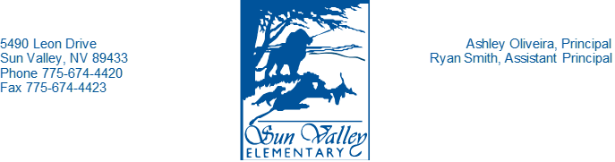

Sun Valley Families,

Welcome to the 2025–2026 school year at Sun Valley Elementary School! We’re excited to kick off another year in the Pride Lands—a community where students, staff, and families work together to make each day meaningful and full of purpose.

At Sun Valley, our mission is clear: we are a community of students, staff, and families who foster positive relationships and ensure that all students achieve at high levels while feeling safe and loved. Our vision continues to drive our work: Sun Valley students will achieve at high levels through student-centered learning, perseverance, and continuous community collaboration.

This year’s theme, "Mission: Possible," speaks directly to the heart of that vision. It reminds us that, with determination and teamwork, no goal is out of reach. Whether it’s mastering a new skill, solving a tough problem, or supporting a peer, every member of our community has an important role to play in turning the seemingly impossible into the possible.

Last year, we saw strong growth in areas like English language development, attendance, and overall academic growth. These gains reflect the incredible efforts of our students and staff—and the unwavering support of families like yours. This year, we are focused on continuing that momentum for all students. We believe that every child can succeed, and we are committed to providing the challenge, support, and care they need to do so.

Thank you for your continued trust and partnership. Together, we’re ready to make this year’s mission not just possible—but powerful.

****With appreciation,

Ashley Oliveira

Proud Principal

*Sun Valley Elementary School*

***SUN VALLEY: SCHOOL STAFF***

Ashley Oliveira –Principal

Ryan Smith – Assistant Principal

|  |  |  |
| --- | --- | --- |
| **Pre-K**  Rosa Mamani  Margarita Botello (Aide)  **Kindergarten**  Karen Avila-Sheffield  Jacqueline Cortez  Bianca Martinez  **First Grade**  Dena Espinoza  Adriana Kenny  Yesenia Rangel-Falcon  Samantha Sidman  Diane Wilkinson  **Second Grade**  Irene Ayala  Sky Baumbach  Olga Quiroz  Kelly Wilson  **Third Grade**  Lisa Ellison  Katie Gaeckle  Erica Hansen  Andy Levandowski  **Fourth Grade**  Kaylin Aytes  Mitchell Brill  Lou Ann McCarthy  Justina Wu-Whittemore | **Fifth Grade**  Alanna Mayo  Amber Niebauer  Hernan Rios  Alejandra Vazquez  **SPED-Strategies**  Andrea Cortez  Heidy Rios  Mirna Murillo (Assistant)  Trudy Warner (Assistant)  **SPED-Resource**  Andrea Torres  TBD  **Psychologist**  Molly Fallon  **Speech**  Gina Lazzarone  **ELL**  Alanna Brady  Sherry Coops  Nancy Sandoval  David Alcantara (Assistant)    **Intervention**  Odalis Gusman-Marquez  Ezekiel Jacinto  **Office**  Charleen Stevens-Secretary  Lilia Guzman – Bilingual Clerk | **Counselor**  Teesha Lane  **School Social Worker**  Jazmyn Horton  **Computers**  Stephanie Mendez-Valenzuela  **Library**  Dana Bothe  **Music**  Kelly Bodtke  **Health Clinic**  Maribel Gomez (Nurse)  Anahis Trejo (Clinical Aide)  **Nutrition Services**  Teri Braunworth  Stephanie Corey  Andrew Serrano  **Boys and Girls Club**  TBD  **Team Up Tutoring**  Barbara Hawkins (Coordinator)  **Facilities Maintenance**  Rose Jeffers (SFC)  Juan Chagolla  Yanet Mora |

*SUN VALLEY ELEMENTARY SCHOOL*



MISSION

Sun Valley Elementary School is a community of students, staff and families who foster positive relationships and ensure that all students achieve at high levels while feeling safe and loved.

VISION

Sun Valley Elementary students will achieve at high levels through student-centered learning, perseverance, and continuous community collaboration.

We show our ***Lion Pride*** by being:

***Safe, Respectful, and Responsible***

**Non-Discrimination Statement**: The Washoe County School District is committed to nondiscrimination on the basis of race, color, national origin or ethnic group identification, marital status, ancestry, sex, sexual orientation, gender identity or expression, genetic information, religion, age, mental or physical disability, military or veteran’s status in educational programs or activities, and employment as required by applicable federal and state laws and regulations. No District employee, including, without limitation, administrators, faculty, or other staff members, nor students shall engage in acts of bullying, harassment, or discrimination on the premises of any public school, school-sponsored event, or school bus in the District. Prohibited behaviors include cyber-bullying, sexual harassment, hazing, intimidation and retaliation.

**Disclaimer:** This document contains references to Board Policies and other documents pertaining to the rules and regulations of the Washoe County School District. The District reserves the right to revise any of these documents during the course of the school year. For the current version of any of these documents, please check the District’s website at <https://www.wcsdpolicy.net/search.php>

*SUN VALLEY: 2025-2026 SCHOOL YEAR CALENDAR*

*SUN VALLEY: 2025-2026 daily schedule*

**Campus Opens** 9:15 Students may enter playgrounds

**1st Bell** 9:25 Students may enter the buildings

**School Day Begins** 9:30 Tardy bell rings

**Lunch**

Kindergarten & 5th 11:30-11:50

1st & 3rd 12:00-12:20

2nd & 4th 12:30-12:50

**Lunch Recess**

Kindergarten & 5th 11:50-12:05

1st & 3rd 12:20-12:35

2nd & 4th 12:50-1:05

**Dismissal** 3:30pm

**Early Release Days (Wednesdays): Dismissal is 2:45\***

**Conference Week (10/24-30): Dismissal is 1:20**

**\*DELAYED START PROCEDURES**

In the event of a bad storm, the TV and Radio Stations will begin announcing DELAYED START of school by 6:00 am. In addition, you will find all information on the district website @www.washoeschools.net, on the WCSD Facebook page, and/or on the Sun Valley ES Facebook page @ [www.facebook.com/SunValleyLionPride](http://www.facebook.com/SunValleyLionPride). You can also call the Snow Hotline at 775-334-8373 at 6am for updates.

In the event of a 2-hour delayed start, school will begin at 11:25 am. School will end at the regular 3:30 pm dismissal time. If a 2-hour delayed start is called on a Wednesday, early release will be cancelled and dismissal will be at 3:30 pm.

Students are NOT to arrive at school until 10 minutes before the delayed start times, as there will be NO playground supervision in the morning and there will be NO before-school programming.

# *sUN VALLEY: Important Phone Numbers, Websites & Links*

Sun Valley ES Office (24-hour voicemail): 674-4420

WCSD Main Office: 348-0200

Snow Hotline (for school cancellations or delays) 334-8373

Boys and Girls Club (Before/After school program): 331-5437

Washoe County Social Services: 784-7301

Washoe County Health Department: 328-2400

Children’s Cabinet: 856-6200

Child Find: 689-2854

Crisis Call Center: 784-8090

WCSD Website: [www.washoeschools.net](http://www.washoeschools.net)

WCSD Homework Policy: <https://tinyurl.com/WCSDHomeworkPolicy>

https://tinyurl.com/WCSDHomeworkPolicy2

WCSD Student E-mail Policy: <https://tinyurl.com/WCSDStudentEmailPolicy>

WCSD Plagiarism and Cheating Policy <https://tinyurl.com/WCSDCheatingPolicy>

WCSD Internet Safety Policy <https://tinyurl.com/WCSDInternetSafety>

WCSD Service Animals Policy <https://tinyurl.com/WCSDServiceAnimals>

WCSD Gender Identity Policy <https://tinyurl.com/WCSDGenderIdentityPolicy>

WCSD Student Records/Info Policy <https://tinyurl.com/WCSDStudentRecords>

Sun Valley ES Website: [www.washoeschools.net/SunValley](http://www.washoeschools.net/SunValley)

Sun Valley ES Facebook Page: [www.](http://www.)facebook.com/SunValleyLionPride



*Sun Valley: Policies and Procedures 2025-2026*

ARRIVAL 9:15 AM

* Supervision of the playground begins at 9:15am. Students may not enter the playground until school staff are on the playground. Students are also not permitted to be in the hallways or buildings before the morning bell (9:25 am) rings. Please make arrangements with our before- and after- school provider if you need to drop your child off prior to 9:15am or cannot pick up your child at dismissal.
* 9:25 am – 1st bell rings to line up
* 9:30 am – Tardy bell rings and instruction begins.
* Tardy students (not in the classroom when the 9:30 am bell rings) are to report to the office as soon as they arrive at school. This is VERY important so that parents do not receive a call in the morning reporting a student absent.
* Students are not be permitted to enter/exit the campus via the front gates. Please use the Kiss and Drop, “Swing Gate” or “Corner Gate”.

DISMISSAL 3:30 PM

* It is imperative that all students are picked up each day at the 3:30pm bell and are safely accounted for by 3:40 pm. Any child not picked up will be expected to wait for an adult in the school office. This should only happen on rare, emergency occasions.
* In the event of an emergency that will result in you being late (after 3:40 pm), please contact the school, and we will keep your child in the main office safely.
* A morning- and after-school program sponsored by an outside agency is available on campus.

PARKING LOT PROCEDURES – “Kiss and Drop”

It is our number one priority to keep all our students, staff, and parents safe while here on our school campus. Each year, we experience safety concerns in our parking lot and surrounding streets. We ask that all families plan ahead, arrive early, and practice patience and kindness towards others during pick up and drop off times. We are asking that all families adhere to the parking lot and driving expectations to keep everyone safe. Please contact the office at 674-4420 if you are interested in supporting us as a Parking Lot Parent Volunteer.

* The front parking lot is for **bus loading and unloading ONLY from 9:10-9:30 am and 3:15-3:45pm.** The front parking lot is for staff parking and parent use from 9:30 am to 3:15 pm, only when there are no busses present in the front parking lot.
* The front parking lot is **not for picking up and dropping off students before and after school.**
* If the orange cones are placed out in the front parking lot entrance or busses are parked there, please do not enter the parking lot.
* Please be aware of the “Do Not Enter” and “No Parking” signs at the front parking lot and do not use this area to enter the parking lot.
* There is a **Parent Pick-Up,** AKA “Kiss and Drop” area behind (east) the school building. Please meet your child here after school. **Parents are expected to drop off and pick up their students without exiting their cars.** Please pull up alongside the green curb and remain inside your vehicle while your students load/unload from your vehicle independently. Please pull forward as space along the green curb becomes available. Please arrive early, be patient, and alert to the traffic patterns. Thank you!
* Students are not permitted to step off the green curb without an adult escort.
* Please do not double park, park in areas that are not parking spaces or block the crosswalk when stopped at a stop sign or while waiting to make a turn.
* Please stop and yield to pedestrians using the crosswalks.
* Avoid any distractions while driving and remind your children to do the same when walking to or from school.
* Please remember to obey all traffic laws and the traffic patterns that have been put in place here at Sun Valley Elementary and in the community along your commute.

If you would like to join our Parent Parking Lot Committee, we will be holding trainings for interested parents throughout the year. Please contact our front office at Sun Valley ES at 775-674-4420 if you would like to volunteer to be a part of this very important Parent Parking Lot Task Force. Together, we can help our children and our students have a safe experience coming to and from school.

We appreciate your support in following and enforcing these safety expectations in our parking lot and surrounding areas.

TRANSPORTATION

If you have any questions or concerns about transportation, please contact the Transportation Department at (775) 353-5900. WCSD Transportation of Students Policy: <https://tinyurl.com/WCSDTransportationofStudents>

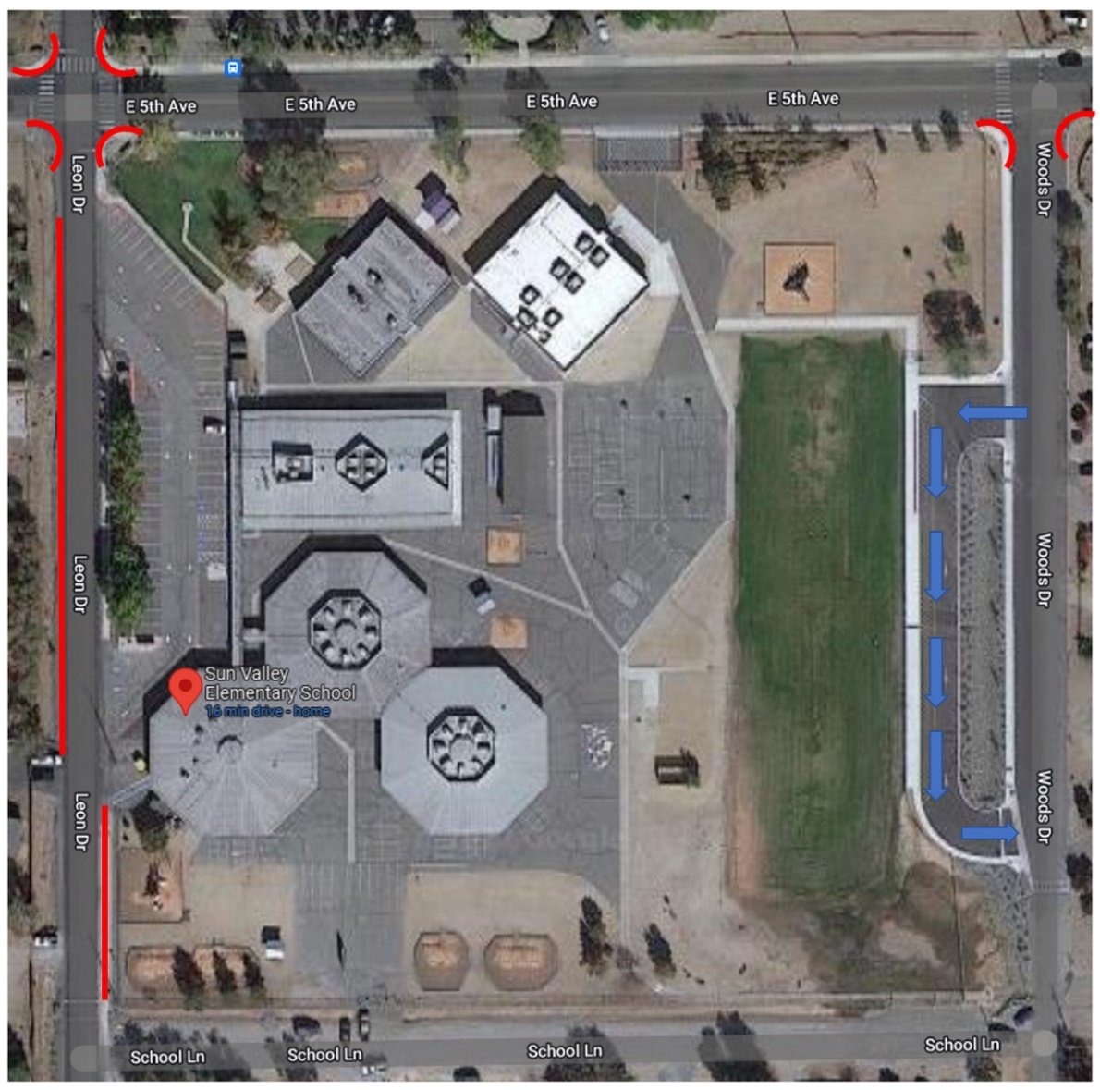

CORNER GATE

SWING GATE

F BLDG GATE

KISS AND DROP

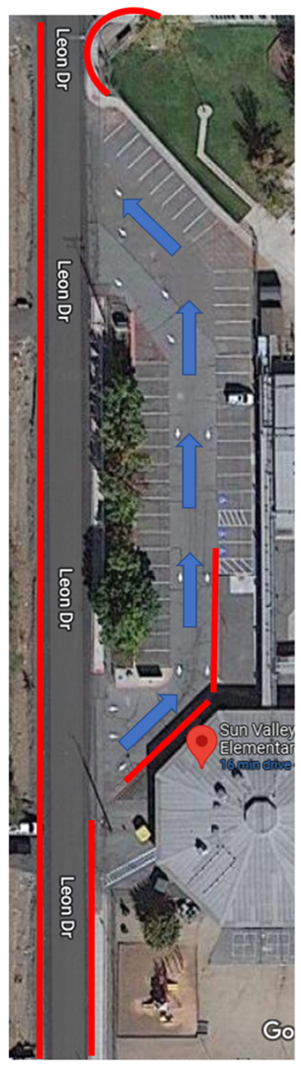

**Please note the following:**

* **There is no parking within 30 feet of any intersection.** This supports visibility for all drivers, keeps our crosswalks clear for pedestrians, and allows for enough space for our busses to turn.
* **There is no parking along the west side of Leon Drive on the dirt shoulder.** This causes Leon Drive to become too narrow, reduces visibility for cars, as well as creates a bottleneck of traffic for all.
* **There is no parking or student drop off permitted alongside the red curb in our parking lot.** This area is reserved for school busses only. Cars parked here, even for a short time, block the parked cars when they are trying to exit. This includes during our before- and after- school programming hours. Please find a parking spot and exit your vehicle. All student drop off is to be conducted on the east side of our campus at the “Kiss and Drop”.
* **All cars must enter the parking lot from the south side of the lot.** Our parking lot is a one-way only to support student and parent safety as well as to alleviate traffic.
* **There is no parking alongside the red curb south of our parking lot (in front of 1st grade playground).** This causes Leon Drive to become too narrow, reduces visibility for cars, as well as creates a bottleneck of traffic for all.
* **Kiss and Drop:** Please only allow your student to load/unload from your car if you are pulled up alongside the Kiss and Drop curb. Please do not wave your child off the curb to cross the street or traffic to your vehicle. We want to keep all students safe, and they should use the crosswalk with an adult to cross the street.

Please keep in mind that all these measures and reminders are simply to help keep your child safe.

Thank you.

HEALTH

* Please call the school and notify the office of the reason for your child’s absence (775-674-4420).
* Please note that ANY absences unaccompanied by doctor’s note are **unexcused absences and count toward your child’s chronic absenteeism rate**.
* Please let the nurse know of any medical needs that your child might have as soon as possible.

SCOOTERS/BICYCLES/ROLLER BLADES/WHEELIE SHOES

Any student riding a scooter or bicycle to school must supply a lock. The school is not responsible for any loss, damage, or theft. Scooters, bikes, skateboards, roller blades are not to be ridden on school grounds. Once students are on school grounds, they will walk their bike, scooter, etc. to the bike rack.

Students must remove and leave at home the wheel from any wheelie shoes if they are worn to school.

MEALS AND SNACKS

* Breakfast:
  + All students will be offered breakfast each morning in the classroom between 9:30 and 9:45am. This is a **free** meal that we encourage all students to partake in.
* Lunch:
  + Students may bring a sack lunch or a “cold” lunch or may choose a **free** lunch served in the cafeteria.
  + Menus are sent home with the students each month.
  + If you will be providing a lunch for your child, please refrain from packing any glass bottles, sodas, or energy drinks.
  + For the health and safety of all students, the sharing of cold lunches is not permitted. If sending your child with cold lunch, please pack single-sized portions of food items for your child to consume during the lunch period.
* Snacks/Birthdays:
  + Our assigned day for snacks/treats is the last Friday of the month (see Parent Calendar for dates for each month’s “Treat Day”). Please communicate with your child’s teacher to arrange for a short snack/treat if you wish to celebrate something special for your child on the last Friday of the month.

# *sUN VALLEY: ATTENDANCE*

* **Your child’s daily attendance at school is imperative to their academic success. Our goal is for all students to achieve an attendance rate of at least 90%.**
* Help your child find success in the following ways:
  + Send your child to school every day.
  + If your child is ill with vomiting, diarrhea or fever, please keep your child home and call the office. These absences are **NOT EXCUSED**, unless accompanied by a doctor’s note**.**
  + As much as possible, schedule appointments for your child outside of school hours.
  + If your child goes to a medical appointment or misses school for a medical reason, send a doctor’s note to the school with your child. Absences accompanied by a doctor’s note are **excused**.
  + Plan any family trips/vacations during the school’s scheduled breaks (see School Calendar on page 6 for dates). Please note that absences from school for family travel, family emergency, inclement weather, or other family related needs are coded as “domestic” and are **unexcused.**
  + On delayed start days, plan ahead and use the extra 2 hours to travel to school with your child safely and to be on time.
  + Communicate often and regularly with your child’s teacher via phone, email, or ClassDojo.
* Please call the school and notify the office of the reason for your child’s absence (775-674-4420). Please note that medical absences unaccompanied by doctor’s note are **unexcused absences** and count toward your child’s chronic absenteeism rate.
* When your child returns to school, if you have not contacted the office, please send a signed note stating the date and the reason for his/her absence.
* The entire attendance policy, WCSD Board Policy 5400, is available on the Student Accounting Department website at <https://tinyurl.com/WCSDStudentAttendance>,

LEAVING SCHOOL EARLY

* Please check in at the front office and bring your Photo ID to pick up your child from school early, or if your child is arriving late to school. **Students will not be released from class until a parent has checked them out from the front office.**
* The parent or legal guardian must complete a signed approved release form (available in our office) to grant permission for someone other than the parent or guardian to pick up their child. This includes step-parents. These forms are available in the front office and are valid for one year.
* WCSD Release of Students during School Hours Policy: <https://tinyurl.com/WCSDReleaseofStudents>

REGISTRATION/WITHDRAWAL

* All students returning to any school in Washoe County, including Sun Valley Elementary School, must have an updated, completed registration for every school year. Registration information must be completed on-line through your Infinite Campus Parent Portal.

INFINITE CAMPUS

* Infinite Campus allows you to follow your student’s progress throughout the year, as well as communicate with the teachers. We recommend that you check your child’s Infinite Campus at least monthly, if not weekly.
* Please keep your Infinite Campus password until your child graduates. If you have a change in phone number or address, please notify the office so that your Infinite Campus can be updated and teachers know how to best get ahold of you.
* Some of the advantages of checking your Parent Portal on a daily/weekly schedule are:
  + Grades
  + Class Assignments
  + Attendance
  + Behavior
  + To-Do list of assignments that are due or overdue
  + Assessment Data (State testing results – SBAC, MAP, etc.)
  + Immunization records
  + Family calendar that organizes all of your children even if they attend different schools
  + A graduation planner

**If you have any questions regarding your parent portal, please call Ms. Lilia Guzman, our wonderful clerical aide, and she will be happy to assist you.**

*SUN VALLEY: AFTER SCHOOL TEAM UP TUTORING*

Sun Valley offers Team Up After-School tutoring for students needing additional academic supports, as space allows. Please contact your child’s teacher to see if Team Up After-School Tutoring would be appropriate for your child.

# *SUN VALLEY: Parent Communication & Counseling*

****CLASS DOJO

In order to provide better communication between home and school, your student’s teacher will encourage you to sign up for Class Dojo to receive at least weekly communication about what is happening in your child’s classroom and at our school! We hope that you will join our Class Dojo community for these important messages and updates.

CONNECT ED

Connect-Ed is the school and district’s communication system. The system will make phone calls to homes each day for student absences. Parents will be notified by phone of upcoming events and important school and district information. School delays and closures will be announced via Connect-Ed as well. It is important that the school has your most recent phone numbers so the system can make its calls. **Please notify the office of any changes to your phone numbers and we can make sure the corrections are in the phone system.**

REPORT CARDS

Report cards are issued on a quarterly basis (4 times per year). They are designed to give you a written report on the educational progress of your child.

PARENT/TEACHER CONFERENCES

Sun Valley Elementary School will be holding one Parent/Teacher Conference week this year (October 24-30, 2025). The students will have early release on those days (1:20pm). Please make every attempt to attend. Parents are also encouraged to schedule a conference with teachers at any time during the year.

COUNSELING & FAMILY RESOURCES

Sun Valley Elementary School has a fulltime school counselor. Our counselor offers classroom guidance, friendship groups, grief counseling groups, and can assist families and children in helping to identify those children who may need assessment testing. Our counselor, as well as our School Social Worker, have helpful information on parenting and community referrals.

HOME VISITS

We are a proud Home Visits school! We have a team of teachers who are excited to visit the homes of as many of our students as possible this year! Home visits are 30-minute visits with you and your family that can take place in your home or another central location so that we can learn more about your child and your family, your hopes and dreams for you child(ren) and anything else that you’d like to share with your teacher visitors! We typically schedule two visits per family: one in the fall semester and one in the spring semester. Please contact our School Counselor at 674-4420 to schedule your home visits!

EMERGENCY INFORMATION

For the safety of your child due to an illness or accident, it is imperative that the school have your current telephone numbers for work and home, as well as updated cell phone numbers. We have Parent/Guardian Update Information Forms in the front office, which you can use to update any important information.

If you plan on being out of town for a day or longer, please let the school know who will be responsible for your child in case of an emergency, i.e., Illness or accident.

# *SUN VALLEY: VISITORS*

In order to keep our students and staff members safe, as well as to maintain a standard of consistency and uninterrupted instruction for our students, visitors are not permitted in classrooms, with the exception of parent volunteers (see below).

For allowable visitors (during soccer games, music performances, district personnel, etc.), all visitors must enter through and check in at the front office where they will sign in and receive a Visitor’s badge; visitors will be required to wear the badge during their entire visit.

WCSD Protocols for Visitors to District Policy: <https://tinyurl.com/WCSDVisitorsPolicy>

# *SUN VALLEY: VOLUNTEERING*

THANK YOU!

We encourage parent volunteers at Sun Valley Elementary School and wish to thank you in advance for your support. When volunteering in a classroom or for a field trip, please check in at the front office to sign in and get your volunteer badge. For the safety of all children, WCSD has a volunteer screening policy. We appreciate your patience and compliance in keeping our school safe.

SCHOOL VOLUNTEER APPLICATION

New this year! Beginning July 1, 2025, all volunteer applications will be submitted online to the school district’s online volunteer management system, Raptor: <https://tinyurl.com/WCSDVolunteerApplication>. Please be mindful that the approval process may take up to three (3) weeks.

WCSD Volunteer Screen and Background Checks Policy: <https://tinyurl.com/WCSDVolunteers>

OVERNIGHT CHAPERONES

If you wish to volunteer as an Overnight Chaperone on a field trip, you must be fingerprinted at least eight (8) weeks in advance of the field trip date, but no sooner than 6 months before the trip. In addition, you will receive a WCSD Volunteer Handbook.

To be fingerprinted for overnight chaperoning, you must take the **School Volunteer Application with an Authorized School Personnel Signature**, as well as your picture ID to the Fingerprint ID and Background Office. Fingerprinting personnel will give you a confirmation notice on the bottom of the form, which you must return to Sun Valley ES’s front office.

The Fingerprint ID and Background office is located at 425 E. Ninth Street in Reno. The office is located in the back on the left side of the building. Fingerprinting can be done from 8:00am-12:00pm and from 1:00pm-4:00pm every Monday through Friday (excluding holidays).

Once you are cleared, please remember to check in through the office and take a volunteer/visitor badge to wear EACH TIME you are in the school.

FIELDTRIPS

If you are volunteering for a field trip, please commit to attending the entire field trip and returning with the students to the school on the school bus. For the safety of all children, WCSD has a volunteer screening policy. We appreciate your patience and compliance in keeping our school safe.

*SUN VALLEY: SOCIAL EMOTIONAL LEARNING & POSITIVE BEHAVIOR SUPPORT*

The Sun Valley Philosophy is to provide a challenging academic program in a safe, nurturing environment.

WCSD Student Behavior Policy: <https://tinyurl.com/WCSDBehavior>

WCSD Student Behavior Manual: <https://tinyurl.com/WCSDBehaviorManualSY24>

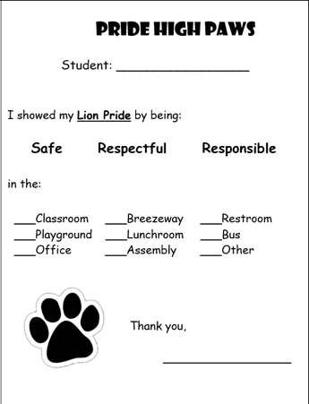

POSITIVE BEHAVIOR & INTERVENTION SUPPORT (PBIS)

* At Sun Valley Elementary School, all students are taught our schoolwide expectations that we ***show our Lion Pride*** by being:
  + Safe
  + Respectful
  + Responsible

When students demonstrate these positive and expected behaviors on campus, they will earn “High Paws”! These tickets can be redeemed once per month at the Student Store for various prizes and school events!

Additionally, we are a Restorative Practices school. We work with our students through all their choices to support them in identifying why they have chosen to engage in particular behaviors, how their behavior may have impacted others and identify which alternative behaviors they could have tried and will do differently next time. We then support our students in finding ways to restore any relationships in need of repair following the incident.

As a parent, you are our greatest partner in encouraging positive behaviors in our students and working alongside our school team as we help our students navigate any bumps in the road along their school journey.

AWARDS & RECOGNITION

* **Student of the Month Awards:** Students who are exemplifying our **Lion Pride Behavior of the Month** (Safe, Respectful, Responsible)each month will be awarded a Student of the Month award and will get a special celebratory lunch that day!
* **Attendance Awards**: There will be many opportunities throughout the year for your child to receive special awards and accolades for their positive attendance behaviors; being on time and present every day! We hope that you will support your child’s academic success by ensuring that they arrive on time to school each and every day!

# 

# *SUN VALLEY: PERSONAL BELONGINGS/TOYS*

All toys and stuffed animals must remain at home as they cause a disruption to your child’s learning.

We are not responsible for loss, theft or damage to any items that your child brings to school or stores/leaves on campus.

# *ELECTRONIC DEVICES*

Please leave all electronics at home. If your child must bring a cell phone or Smart Watch to school, it must be kept off and in their backpack throughout the school day.

If a student must bring a cell phone or Smart Watch, it is not to be carried into classrooms during assessments, semester exams or other testing situations.

If you must talk with your student during the day, please call the office.

WCSD Use of Personal Electronic Device by Student Policy: <https://tinyurl.com/WCSDPersonalElectronicDevices>

# *LOST & FOUND*

Please mark your child(ren)’s name on all lunchboxes, sweaters, coats and personal belongings for easy identification and so that staff can return lost items to your child directly.

If your child has lost an item, you may come to the school and check our Lost and Found Bins.

# *SUN VALLEY: BULLYING & HARASSMENT*

The administration and staff at Sun Valley Elementary School take bullying reports very seriously. Please let your child know that if they do not feel safe they must notify their teacher, administrator or any staff member of the school so that we can assist your child immediately.

Please call the school at 775-674-4420 if you have any questions or concerns about this issue.

WCSD Safe & Respectful Learning Environment Policy: <https://tinyurl.com/WCSDSafeRespectfulLearing>

WCSD Student Bullying & Harassment Policy: <https://tinyurl.com/WCSDBullyingPolicy>

# *SUN VALLEY: EMERGENCY PROCEDURES*

The district has emergency procedures in place for staff and students which are practiced school wide on a regular basis. We will practice one drill per month, per state procedures, even in the cold weather. Throughout the school year we plan on practicing all three steps of our evacuation plan as well as stay put procedures. The best thing we can have in an emergency is a plan and the knowledge that comes from practicing it before we need to use it in a true emergency.

EVACUATION PLAN (Fire Drill Bell – Exit Out of Building)

Each classroom has an assigned spot on the school yard as their first step to go to and account for all members of the class. All persons in the building must evacuate when the fire bell rings.

PARENT REUNIFICATION PROCEDURE

In the event that a school has an emergency incident and it is appropriate to send students home, the reunification procedure will be as follows:

* Parents will be notified by the school district where to report to reunite with their child. Photo ID will be required to release your child to you.

*SUN VALLEY: DRESS CODE*

CLOTHING

Sun Valley Elementary School has a school uniform which is enforced on a daily basis.

WCSD Student Uniforms Policy: <https://tinyurl.com/WCSDStudentUniforms>

Student attire consists of the following:

Shirts:

· SVES logo navy (dark) blue or black polo shirt (can be purchased through Kate’s Logos @ kateslogos.com)

· Plain navy (dark) blue or black polo shirt (can be purchased at Walmart or other clothing retailers)

Pants:

· Khaki, navy (dark) blue, or black pants, capris, shorts, or skorts. Jeans, free of holes, are permitted

· Students are not permitted to wear cut-off pants, sweats, or pajamas

Sweatshirts:

· Navy (dark) blue or black crewneck or SVES logoed hoodie (for purchase)

Shoes:

· Closed-Toe Shoes

· Students are not permitted to wear slippers, sandals, or open-toed shoes

Other**:**

· Hats, beanies, and hoodies are not permitted to be worn indoors

Throughout the school year, students will have opportunities to “purchase” Free Dress Days with the Pride High Paws that they earn for exhibiting their Lion Pride Behaviors (Safe, Respectful, Responsible). All WCSD dress code rules and expectations are enforced in order to maintain a productive, safe, learning environment. You may refer to the full dress code rules for Washoe County School District at <https://tinyurl.com/WCSDStudentDressCode>.

