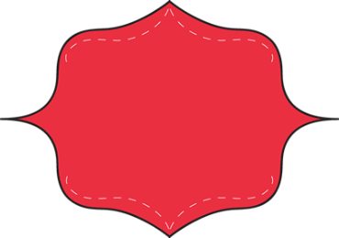
Use backspace to delete each of the colored words.
Activity 1:
Backspacing

I am am in computer class. I am practicing deleting random words. Once I delete the those extra words, it will make much more sense. I highlight the word I want to delete the and press a backspace or delete. Then shazaam the word is gone!
Resize the two pictures below.
Activity 2:
Resizing
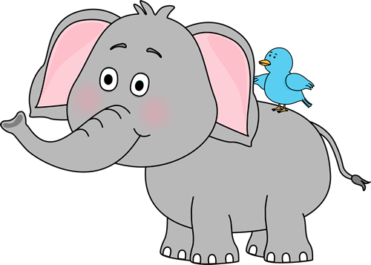
Make this picture smaller:

Make this picture bigger:


Activity 3:
Clipart
Copy & Paste
Copy  and paste the correct number of clip art pictures in the number column.

1 | 2 | 3 | 4 | 5


Change the font color to match each color word below:
Activity 4:
Font Colors

Yellow
Red
Blue
Green
Orange
Pink
Purple
Grey
Activity 5:
Correct Typing
Retype each sentence in the white box below. Use the shift key to make a capital letter!
I go to school.
I like many subjects.
What are you reading?
How old are you?
Learning is fun!

