Middle School Nonfiction Text Analysis with CommonLit
Practice reading nonfiction text is critical to helping you build stamina and engage with the type of reading and writing you will frequently encounter outside of school. This assignment allows you to choose what you want to read about so that you can work on your reading comprehension skills while reading about something you find interesting.

Task: Follow the steps and grade-level link to the CommonLit website. Read all steps first!
Step 1: Follow your grade-level link below and choose ONE article to read for each day of class during distance learning. You will see many nonfiction, grade-level appropriate articles to select from when you use the links below.
Grade 9
Grade 10
Grade 11
Grade 12
Step 2: Complete ALL of the Assessment Questions and ONE of the Discussion Questions to respond to.
Sample Article
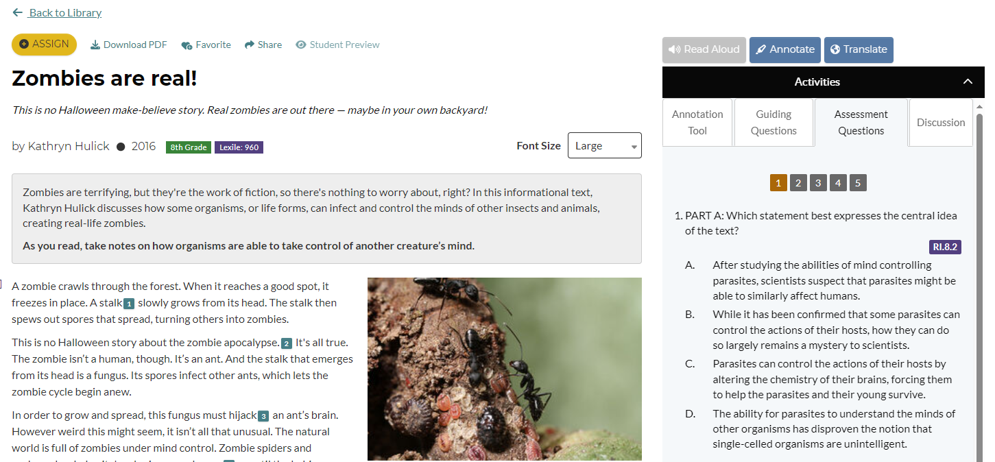

Step 3: Turn in your work to your teacher. Your teacher might ask you to write your answers on a separate sheet of paper or to turn in online via Canvas.

