**Clever**

**Clever** is a portal for students to login to online programs your child’s classroom teacher may be using.

**The directions to login at home are as follows:**

**Note:** Students will need their student ID and password used to login to the computer at school in order to login to Clever

**STEP 1:**  Navigate to the district website. [www.washoeschools.net](http://www.washoeschools.net)

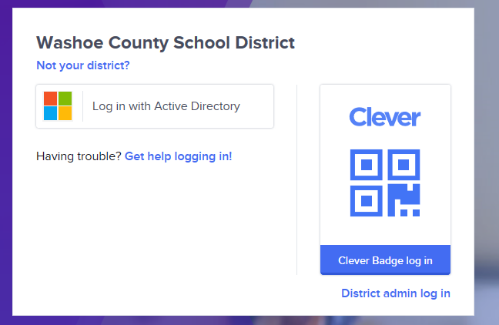**STEP 2:** Click on the Students and Parents tab

**STEP 3:** Click on Clever Log In

**STEP 4:**  Click “Log in with Active Directory”

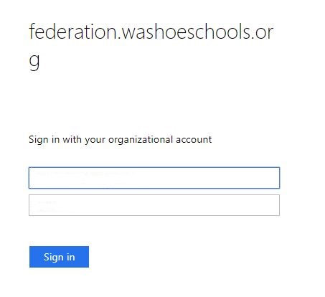

***Enter password here***

***studentID*@washoeschools.org**

**STEP 5:** Log in with your username and password:

**Username:** *Student ID*@washoeschools.org

**Password:**  password used to login to the

computer at school

**Now that you have logged in to Clever, your child can access many of the programs that the teacher uses in their classroom.**