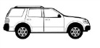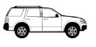C:\Users\wzastawniak\Desktop\parking lot clipart\car 3.jpgC:\Users\wzastawniak\Desktop\parking lot clipart\car 3.jpg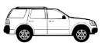C:\Users\wzastawniak\Desktop\parking lot clipart\car 3.jpg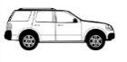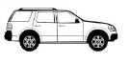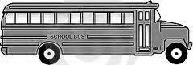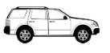C:\Users\wzastawniak\Desktop\parking lot clipart\car 3.jpg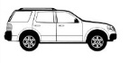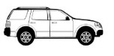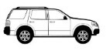C:\Users\wzastawniak\Desktop\parking lot clipart\car 3.jpgC:\Users\wzastawniak\Desktop\parking lot clipart\car 3.jpg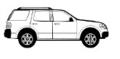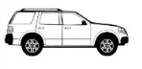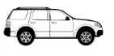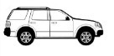C:\Users\wzastawniak\Desktop\parking lot clipart\car 3.jpg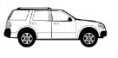

**No parking in any red zone/fire lane at any time.**

**No parking in any red zone/fire lane at any time.**

**NO PARKING, STOPPING, STANDING, OR WAITING**

**\*\*RESTRICTED AREA 8:45am-4:00pm** BUSES, DAYCARE VANS, & STAFF ONLY BETWEEN CROSSWALKS**

Park & Walk

If you choose to walk your child to the playground in the mornings, or pick them up on the playground after school, there are three parking choices:

1) park on Archimedes Lane and use the steps provided, 2) park on Robb Drive which has been approved for before and after school parking, 3) park in any spot that is *not marked* “STAFF” on the east side of the school.

It is best to choose a pick-up spot that will be used daily. Siblings need to also have a meeting spot outside the building.

**ONE WAY**

**ONE WAY**

Robb Drive Robb Drive Robb Drive

Archimedes Lane Archimedes Lane Archimedes Lane

*ROLLAN MELTON ES* \*\***5 MPH AT ALL TIMES\*\***

**Drop-off/Pick-up Zones “Airport Style”** Drop-off/Pick-up Zones are located on the east and west side of the school. Drop-off/Pick-up Zones are designated for continuous flow of traffic. Students may enter or exit vehicles on the passenger side of the car. Vehicles MAY NOT pull in perpendicular to the curb, idle, or sit and wait in the striped Drop-off/Pick-up Zones. **Instruct your child to stay on the yellow curb until you circle around and STOP.**