

**Social Media**

**Resources and References**

**Articles**

How Technology and Social Media Assists People with Disabilities. Thompson, Vilissa.

<http://www.socialworkhelper.com/2013/08/21/how-technology-and-social-media-assists-people-with-disabilities/>

For People with Disabilities, Social Media is Home and the Welcome Mat is Worn. Di Tosti, Carol.

<http://blog.themobilityresource.com/blog/post/for-people-with-disabilities-social-media-vs-traditional-media-social-is-king>

Social Media and People with Disabilities: Building Online Networks to Enhance Community Engagement and Create a Level Playing Field Lisa Lehmann

<http://aaidd.org/docs/default-source/board-minutes/view-presentation-slides.pdf?sfvrsn=0>

<https://www.youtube.com/watch?v=txizmOUTg9w>

A Word About Social Networking. Department of Labor.

<http://www.dol.gov/odep/topics/youth/softskills/SocialNetworking.pdf>

Maslow’s Hiearchy of Social Media. Wordpress.

<http://socialmediaandtheself.wordpress.com/2013/10/21/maslows-hierarchy-of-social-media/>

SociAbility: Social Media for People with a Disability. Holler, Scott. Media Access Australia.

<http://www.mediaaccess.org.au/sites/default/files/files/MAA2657-%20Report-OnlineVersion.pdf>

District Made Video Helps Win Funding Support for AT. WCSD. (Video and article)

[http://donjohnston.com/district-made-video-helps-win-funding-support-for-at/#.VDrznfldWSo](http://donjohnston.com/district-made-video-helps-win-funding-support-for-at/)

**Disclosure**

The 411 on Disability Disclosure: A Workbook for Youth with Disabilities

<http://www.ncwd-youth.info/411-on-disability-disclosure>

Cyber Disclosure for Youth with Disabilities

<http://www.ncwd-youth.info/cyber-disclsoure>

**Facebook**

100 Ways You Should be Using Facebook in the Classroom – Updated. OnlineCollege.org

<http://www.onlinecollege.org/2012/05/21/100-ways-you-should-be-using-facebook-in-your-classroom-updated/>

50 Reasons to Invite Facebook Into Your Classroom. Mindshift.

<http://blogs.kqed.org/mindshift/2011/08/50-reasons-to-invite-facebook-into-your-classroom/>

**Twitter**

A Visual Guide to Twitter for Beginners (poster). Edudemic.com

<http://www.edudemic.com/a-visual-guide-to-twitter-for-beginners/>

100 Ways to Teach with Twitter. Walsh, Kelly. Emerging EdTech.

(note how many ways there are to share article)

<http://www.emergingedtech.com/2010/02/100-ways-to-teach-with-twitter/>

The Teacher’s Guide to Pinterest. Edudemic.

<http://www.edudemic.com/guides/the-teachers-guide-to-pinterest/>

**Pinterest**

How Kids Can Use Pinterest in the Classroom. Pinterest Board.

<http://www.pinterest.com/acisdpins/how-kids-can-use-pinterest-in-the-classroom/>

10 Ways to Use Pinterest in the Classroom

<http://teachbytes.com/2012/03/10/10-ways-to-use-pinterest-in-the-classroom/>

**Instagram**

10 Ways to Use Instagram in the Classroom

<http://www.weareteachers.com/blogs/post/2014/08/07/10-ways-to-use-instagram-in-the-classroom>

Teaching with Instagram

<http://www.pearsonschoolsystems.com/blog/?p=953#sthash.vSesxM35.dpbs>

Instagram in the Classroom – Pinterest Boards

<http://www.pinterest.com/uhighlibrary/instagram-in-the-classroom/>

**Other resources for using websites and Web 2.0 tools to increase engagement and improve writing skills:**

Twitter, Instagram and Pinterest in the Classroom. Scholastic.

<http://www.scholastic.com/teachers/top-teaching/2014/04/twitter-instagram-and-pinterest-classroom>

Social Media Websites Can be a Powerful Aid in Writing Assignments (with 5 examples)

<http://www.emergingedtech.com/2013/04/social-media-websites-can-be-a-powerful-aid-in-writing-assignment-with-5-examples/>

Twelve Essentials for Technology Integration**.** Byrne, Richard

<http://content.yudu.com/Library/A18dcc/TwelveEssentialsforT/resources/1.htm>

Wiki: Top 20 Must Have Web 2.0 Resources for Every 21st Century Classroom

<http://web20guru.wikispaces.com/Web+2.0+Resources>

**Internet Safety**

Internet Safety for Teachers and Students

<http://ciese.org/internetsafety.html>

SafeKids.com Online Safety and Civility

<http://www.safekids.com/2010/08/19/controlling-where-facebook-places-puts-you/>

[FEMA Online Safety Rules for Kids](http://www.fema.gov/kids/on_safety.htm)

<http://www.ready.gov/kids>

**Apps**

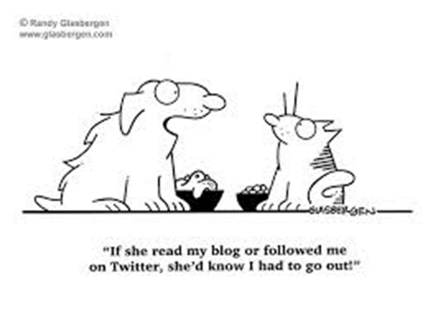Updated comprehensive list of special education apps

[**http://www.spectronics.com.au/apps-for-special-education**](http://www.spectronics.com.au/apps-for-special-education)

Co:Writer

iAnnotate

PaperPort Notes

Ginger

Dragon

iOS 8 Word Prediction (not an app)

Speak feature in Accessiblity in iDevices

Animoto

FlipAGram

**Just a few examples of people with disabilities using social media:**

Persons with Disabilities Blogs

List of blogs – E-Bility: <http://www.e-bility.com/links/blogs.php>

Verve/The Mobility Resource; a Blog about All Things Disability

<http://www.themobilityresource.com/blog>

 JJsList Blog: Where Business and People with Disabilities Connect

<http://www.jjslist.com/blog/?gclid=CMCy7_Hwz7cCFa5xOgodJgcAog>

Disability Blog

<http://usodep.blogs.govdelivery.com/>

Bloom! Parenting Kids with Disabilities

<http://bloom-parentingkidswithdisabilities.blogspot.com/>

Star News Online: Endess Options for all Disabilties

<http://disabilities.blogs.starnewsonline.com/category/social-media/>

Disability Webisode on YouTube

[My Gimpy Life](http://www.youtube.com/user/MyGimpyLife)

Handicap This!

Inspire Series

E-zines related to disabilities

[http://www.disabilityscoop.com/](http://www.disabilityscoop.com/2013/06/03/globally-struggling-unicef/18081/)

Blog Talk Radio

The Coffee Klatch: [Special Needs Radio](http://thecoffeeklatch.com/child-and-adolescent-mental-illness-and-related-disorders-best-interviews-on-the-web/) Twitter: @TheCoffeeKlatch

**Assistive Technology**

List of Screen Readers (add Snap and Read from Don Johnston)

<http://www.disabled-world.com/assistivedevices/computer/screen-readers.php>

Word Prediction software

List of software: <http://www.sc.edu/scatp/ld_prediction.htm>

iOS 8

Speech to Text

List of Speech to Text software and apps

<http://en.wikipedia.org/wiki/List_of_speech_recognition_software>

Eye Gaze

Tobii: <http://www.tobii.com/>