# Washoe County School District LogoThank you for your student records request!

Effective July 1, 2019 in an effort to provide better and more secure service to our students ALL student records requests, special education records requests, background verifications, corporate verifications, corporate information requests, transcript requests, must be made online using our automated student record / information request system.

***Fax, phone calls, email and mail will no longer be accepted.***

<https://washoeschoolsnv.scriborder.com/>Click on the appropriate application.

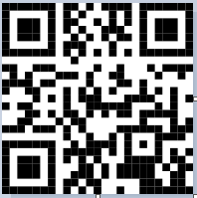

Use your Iphone and/or Smart Phone Camera to take you directly to Washoe County School Districts - ScribOrder

Thank you,

Washoe County School District Student Records

380 Edison Way, Ste. 102

Reno, NV 89502

(775) 861-4428