Atomic Structure Worksheet Name:
Period:

- Name the three particles of the atom and their respective charges are:
a.
b.
c.

- The number of protons in one atom of an element determines the atom’s
, and the number of electrons determines
of an element.

- The atomic number tells you the number of in one atom of an element. It also tells you the number of in a neutral atom of that element. The atomic number gives the “identity “of an element as well as its location on the Periodic Table. No two different elements will have the atomic number.

- The of an element is the average mass of an element’s naturally occurring atoms, or isotopes, taking into account the of each isotope.

- The of an element is the total number of protons and neutrons in the of the atom.

- The mass number is used to calculate the number of in one atom of an element. In order to calculate the number of neutrons you must subtract the from the .

- Give the symbol and number of protons in one atom of:
Lithium Bromine
Iron Copper
Oxygen Mercury
Arsenic Helium

- Give the symbol and number of electrons in a neutral atom of:
Uranium Chlorine
Boron Iodine
Antimony Argon

- Give the isotope symbol and number of neutrons in one atom of the following elements. Show your calculations.

Barium – 138 Sulfur – 32
Carbon – 12 Hydrogen – 1
Fluorine – 19 Magnesium – 24
Silicon - 28 Mercury – 202
- Name the element which has the following numbers of particles. Be specific. (Include charges and mass numbers where possible.)

26 electrons, 29 neutrons, 26 protons
53 protons, 74 neutrons
2 electrons (neutral atom)
20 protons
86 electrons, 125 neutrons, 82 protons (charged atom)
0 neutrons

- If you know ONLY the following information can you always determine what the element is? (Yes/No).
number of protons
number of neutrons
number of electrons in a neutral atom
number of electrons
Name:

On the Inside
Part l: Label the parts of this atom (nucleus, protons, electrons, neutrons)
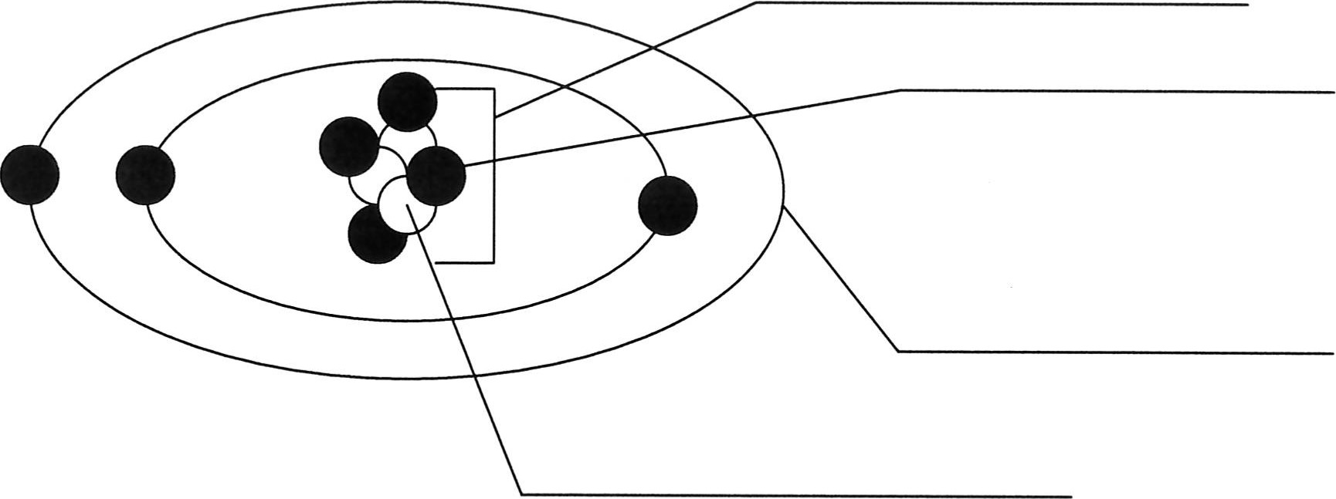
Part 2: Answer these:

1. The subatomic particle with no electrical charge is the 2. The subatomic particle with a positive charge is the 3. The subatomic particle with a negative charge is the 4. There are the same number of these two particles in an atom 5. The atomic number is the same as the number of

- Where is most of the mass of an atom located?

- Which particles account for the mass of the atom? (Atomic mass or mass number) and

8.Com lete the followin table
Symbol | Atomic Number | Number of Protons | Number of Neutrons | Number of Electrons | Mass
 | 9
- The atomic number is the number of in one atom of an element. It is also the number of in a neutral atom of that element. The atomic number gives the "identity "of an element.
No two different elements will have theatomic number.
- Theof an element is the average mass of an element 's naturally occurring atoms, or isotopes, taking into account theof each isotope.

- In order to calculate the number of neutrons you must subtract the from the
- Give the symbol and number of protons in one atom of:
Lithium Mercury Iron
- Com lete the table below.
Symbol | Atomic Number | Mass Number | Number of Protons | Number of Electrons | Number of Neutrons
23
 |  | 39 |  | 19
 |  |  | 38 | 38 | 50
 | 20 | 40
Ions
+2
-1
Isoto es
 |  | 110 | 47
36S
26M
- Draw a Bohr model for the following:
Argon (18) Magnesium (12)
- Complete the following with the terms "new element", ion, isotope, or molecule.
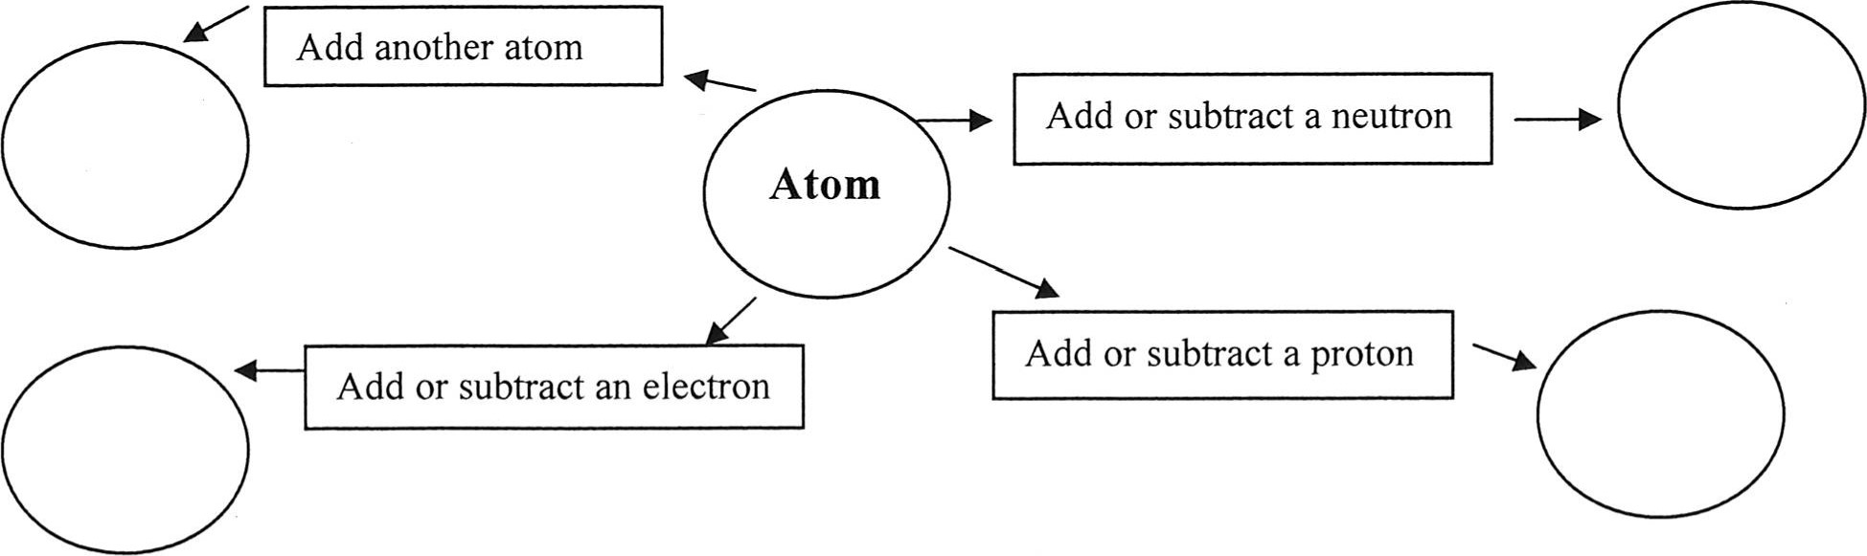
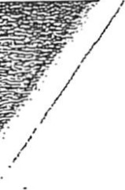
Name: Period: Date:

Atomic Structure
You can become mote fafY1iliar with the atomic stfucture of some elements by completing the chart. You have been given enough inf0Émation to fill in all the blahks. (There is no need to use a periodic table.)
Sub stance | S ymbol | Atomic  Number | Mass Number | Number of Protons | Number of N eutrons | Number of electrons
H e Iium |  | 2
M a gne sium |  | 12 |  |  | 12
Zinc |  | 30 | 65
Bromine |  |  | 80 |  |  | 35
A luminum |  |  |  | 13 | 14
U ranium |  |  |  |  |  | 92
S o d ium |  | 11 |  |  | 12
Hydrogen |  | 1 | 1
C a lc ium |  |  | 40 | 20
S ilver |  |  |  | 47 | 61
M ercury |  | 80 | 201
Iodine |  |  | 127 | 53
P o tassium |  |  |  |  | 20 | 19
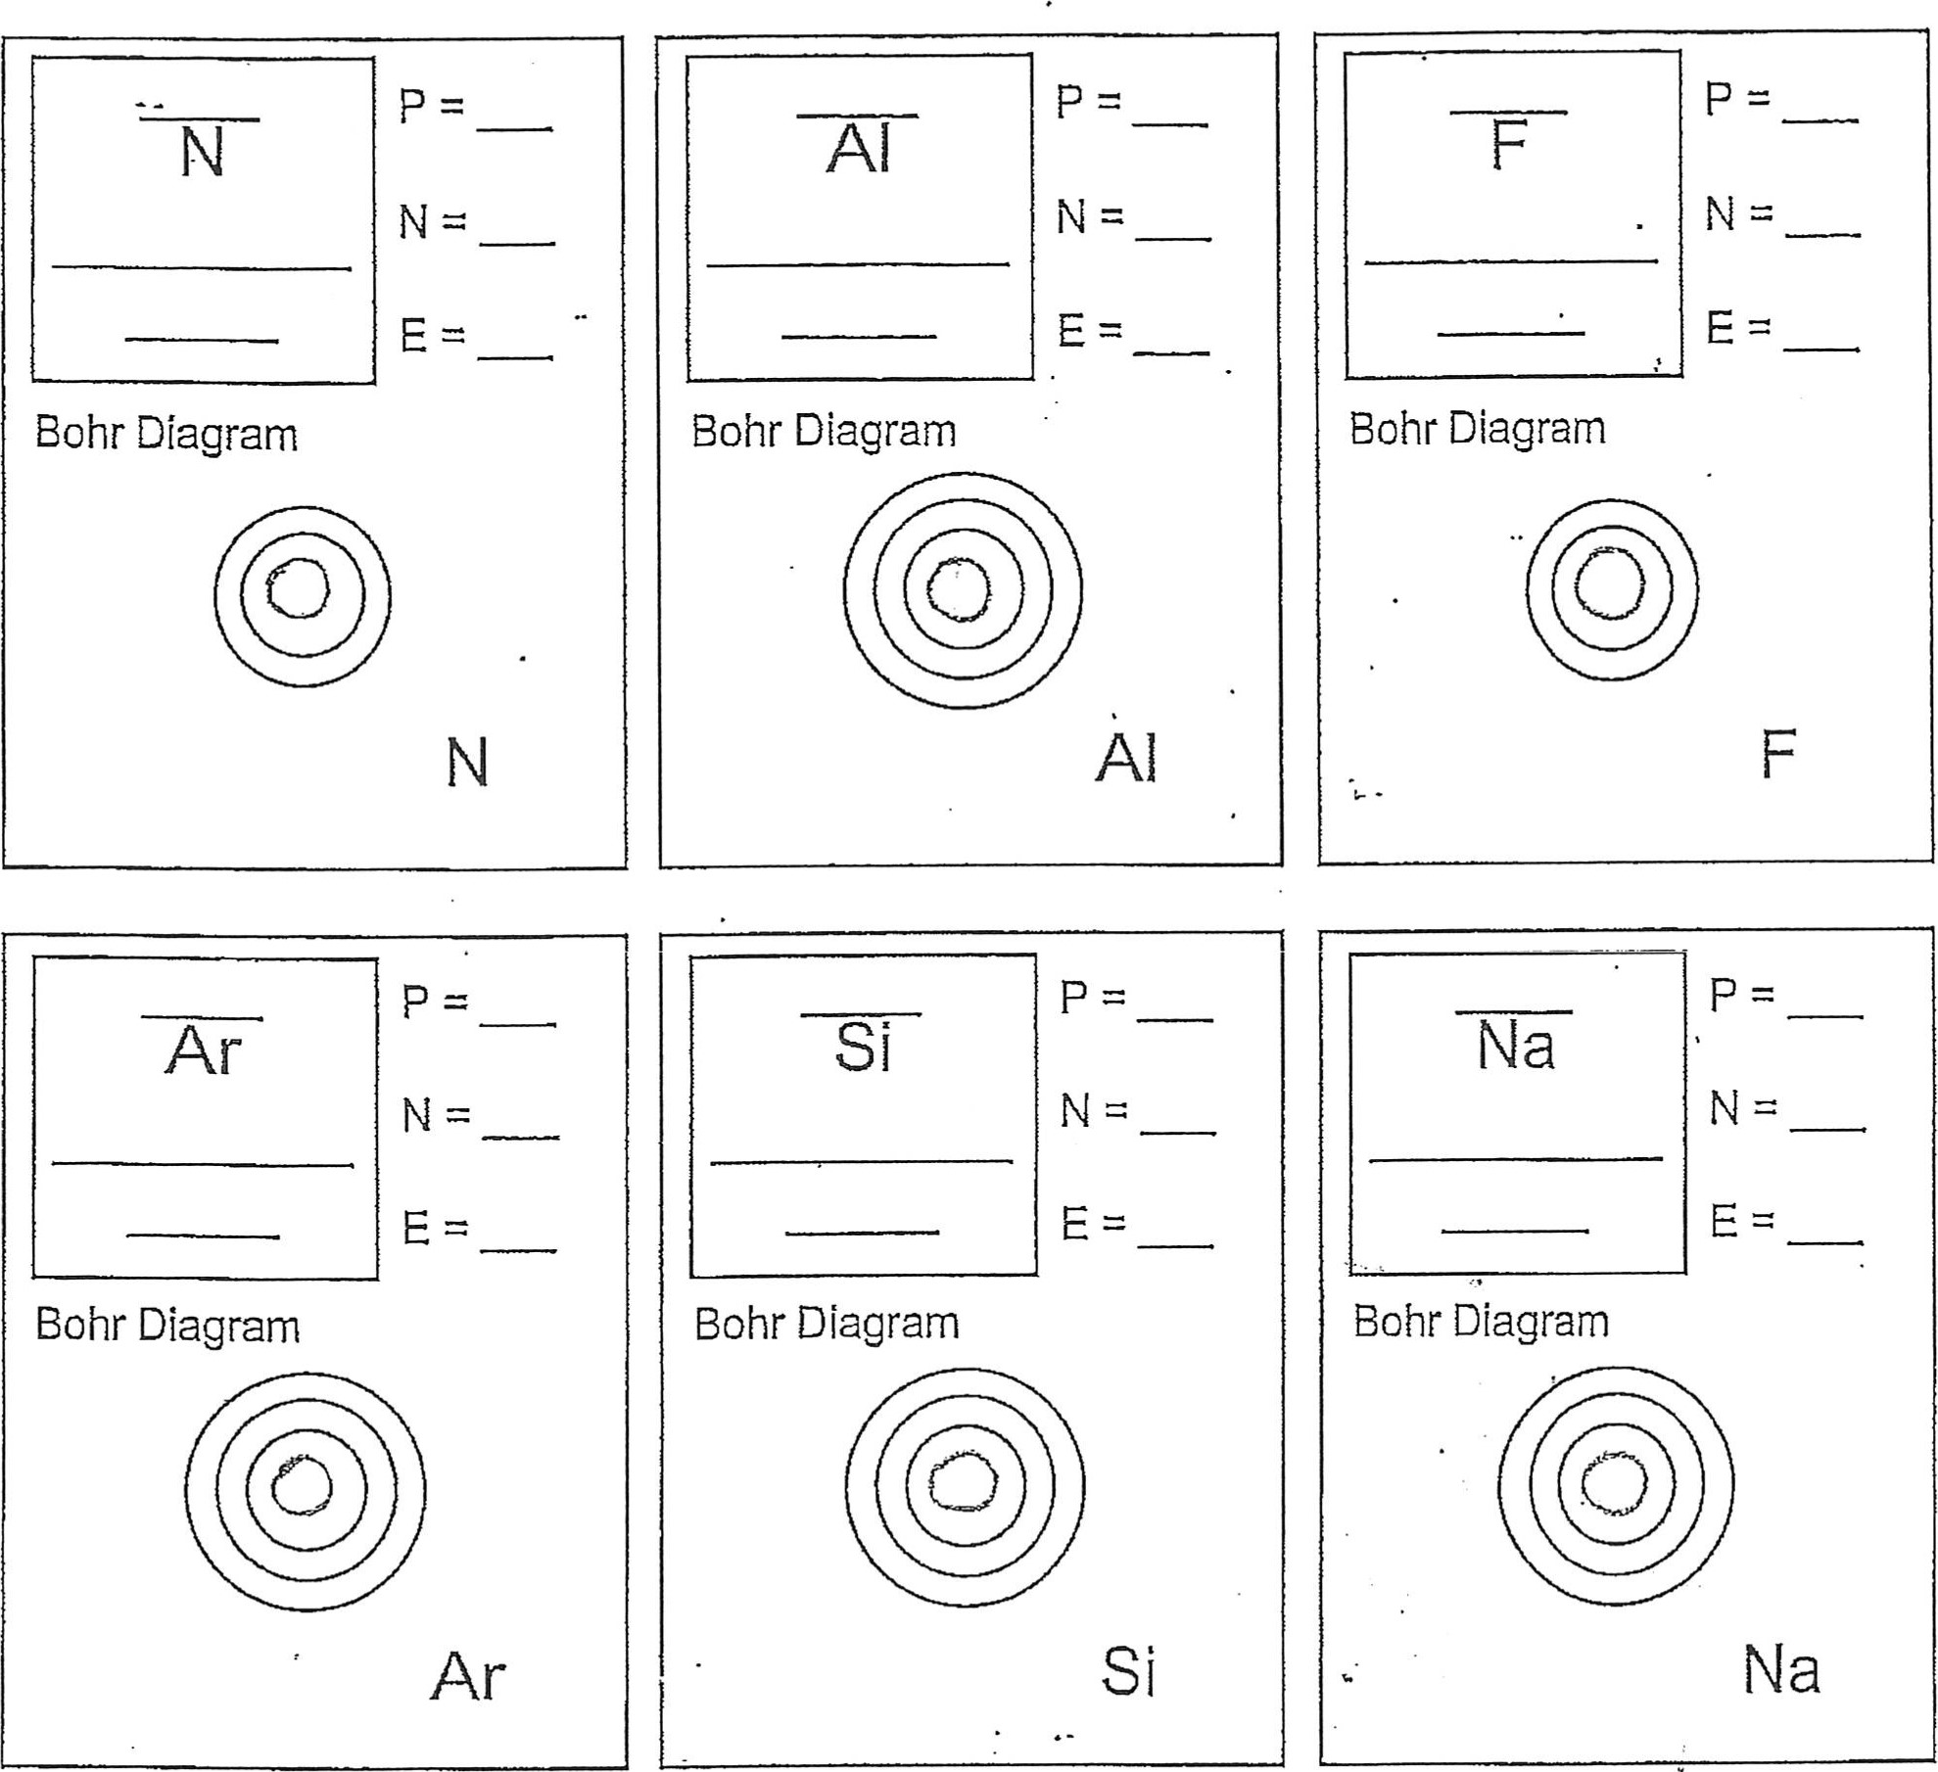
  Be
  Bohr Diagram
  Be
  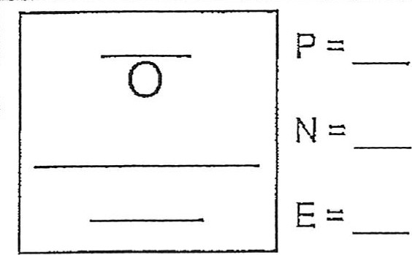
  Bohr Diagram
  Cl
  Bohr Diagram
  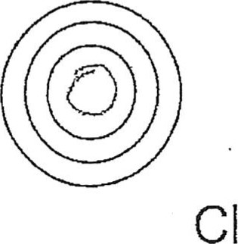

Physical Science Name/Per/Due date______________
Valence Electron Practice

Directions: Give the total number of electrons and the number of valence electrons for each element listed below.

- Hydrogen 2. Lithium

- Beryllium 4. Carbon

- Fluorine 6. Neon

- Magnesium 8. Chlorine

- Arsenic 10. Krypton

- Barium 12. Tin

- Iodine 14. Aluminum

Directions: Give the element names for the element in the given period with the given number of valence electrons.

15. 2nd period, 5 valence electrons 16. 5th period, 1 valence electron

17. 3rd period, 7 valence electrons 18. 6th period, 8 valence electrons

19. 4th period, 3 valence electrons 20. 3rd period, 6 valence electrons

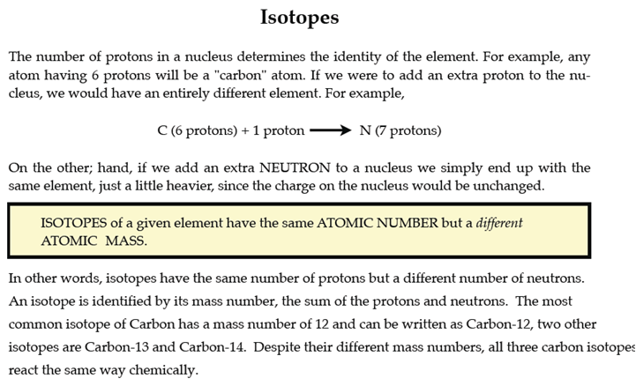

PART I. Answer the questions based on the above reading.

1. What is an isotope? _____________________________________________________________

________________________________________________________________________________

2. What does the number next to isotopes signify? _______________________________________

________________________________________________________________________________

3. How can you tell isotopes of the same element apart? __________________________________

________________________________________________________________________________

PART II. For each of the following isotopes, write the number of protons, neutrons, and electrons. Assume all atoms are neutral.
 | Carbon-12 | Carbon-13 | Carbon-14
# of protons
# of neutrons
# of electrons
 | Chromium-58 | Chromium-63
# of protons
# of neutrons
# of electrons

 | Nitrogen-15 | Nitrogen-20
# of protons
# of neutrons
# of electrons

 | Sulfur-23 | Sulfur-25
# of protons
# of neutrons
# of electrons

 | Selenium-50 | Selenium-55
# of protons
# of neutrons
# of electrons
 | Sodium-12 | Sodium-20
# of protons
# of neutrons
# of electrons

PART III. Fill in the isotope names and any missing information on the chart. Use your periodic table and the information provided. Assume all atoms are neutral.

# of protons | 25
# of neutrons | 17 | 15
# of electrons

# of protons | 32
# of neutrons | 30 | 32
# of electrons

# of protons
# of neutrons | 48 | 51
# of electrons |  | 46
# of protons
# of neutrons | 113 | 111
# of electrons | 55
 | Iron- | Iron-
# of protons
# of neutrons | 27 | 30
# of electrons
 | Iodine- | Iodine-
# of protons
# of neutrons | 32 | 35
# of electrons

 | Germanium- | Germanium-
# of protons
# of neutrons | 33 | 36
# of electrons
 | -10 | -12
# of protons |  | 6
# of neutrons
# of electrons | 6
 | -54 | -56
# of protons | 24
# of neutrons
# of electrons
 | -22 | -25
# of protons
# of neutrons
# of electrons | 11

