Document 1

Chinese Exclusion Act (1882)

Background:  
*Enacted on May 6, 1882, the Chinese Exclusion Act placed a ban on Chinese immigrants entering the United States or being naturalized as U.S. citizens for 10 years. Originally vetoed by President Chester Arthur, the president eventually signed the law after some minor alterations. The Chinese had been entering the country in record numbers for several years previously, particularly in California, and were typically forced to work for extremely low wages and live in conditions of poverty. Many of them lived as near slaves while employed building railroad lines across the West. They were also frequently victims of attacks by workingmen and other immigrant groups, who believed the Chinese were taking jobs away from them.*

Transcript of Chinese Exclusion Act (Excerpted):  
  
An act to execute certain treaty stipulations relating to Chinese.   
  
WHEREAS, in the opinion of the Government of the United States the coming of Chinese laborers to this country endangers the good order of certain localities within the territory thereof: Therefore,   
  
Be it enacted by the Senate and House of Representatives of the United States of America in Congress assembled, That from and after the expiration of ninety days next after the passage of this act, and until the expiration of ten years next after the passage of this act, the coming of Chinese laborers to the United States be, and the same is hereby, suspended; and during such suspension it shall not be lawful for any Chinese laborer to come, or, having so come after the expiration of said ninety days, to remain within the United States.   
  
Section 10. That every vessel whose master shall knowingly violate any of the provisions of this act shall be deemed forfeited to the United States, and shall be liable to seizure and condemnation in any district of the United States into which such vessel may enter or in which she may be found.   
  
Section 12. That no Chinese person shall be permitted to enter the United States by land without producing to the proper office of customs the certificate in this act required of Chinese persons seeking to land from a vessel. And any Chinese person found unlawfully within the United States shall be caused to be removed therefrom to the country from whence he came, by direction of the President of the United States, and at the cost of the United States, after being brought before some justice, judge, or commissioner of a court of the United States and found to be one not lawfully entitled to be or remain in the United States.   
  
Section 13. That this act shall not apply to diplomatic and other officers of the Chinese Government traveling upon the business of that government, whose credentials shall be taken as equivalent to the certificate in this act mentioned, and shall exempt them and their body and household servants from the provisions of this act as to other Chinese persons.   
  
Section 14. That hereafter no State court or court of the United States shall admit Chinese to citizenship; and all laws in conflict with this act are hereby repealed.   
  
Section 15. That the words "Chinese laborers," whenever used in this act, shall be construed to mean both skilled and unskilled laborers and Chinese employed in mining.

"Chinese Exclusion Act (1882)." *American History*. ABC-CLIO, 2013. Web. 11 Oct. 2013.

Document 2

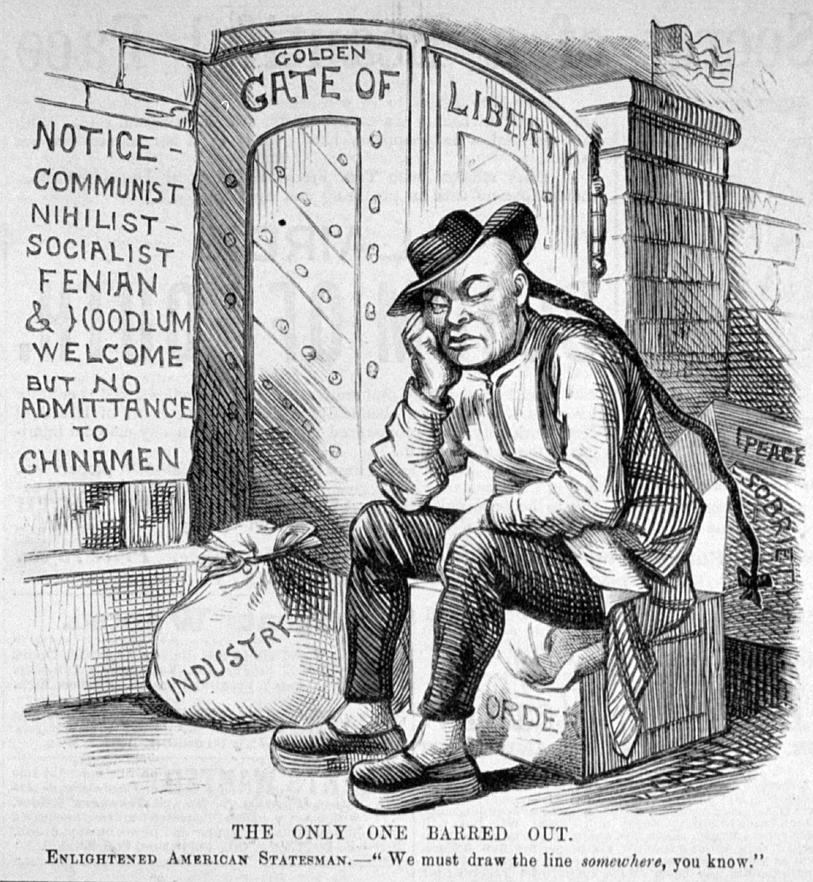

Document 3

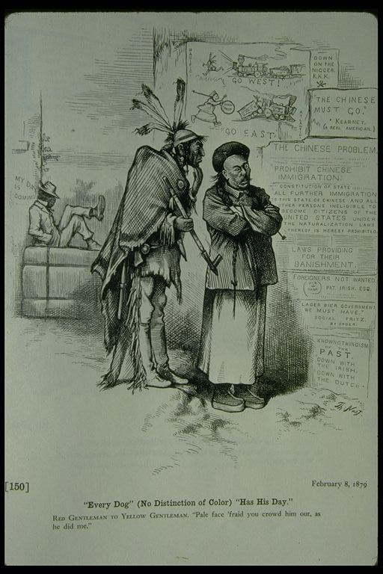

Document 4

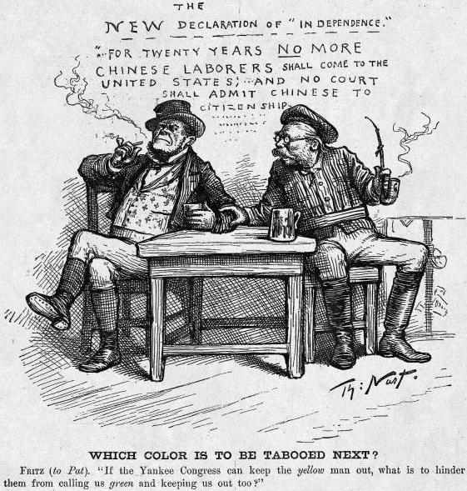

After reading each of the documents, answer the following questions:

*Document 1:*When was the *Chinese Exclusion Act* created? __________________________________________

What words or phrases in the document help you to understand the meaning of the word *Exclusion*?  
________________________________________________________________________________________________________________________________________________________________

The *vessel* in *Section.10* has multiple meanings. What does the word often mean? How is it used in this context? ______________________________________________________________________  
________________________________________________________________________________

What are the two things that this *Act* prohibits? ___________________________________________  
________________________________________________________________________________________________________________________________________________________________

Who is exempt from this *Act*? (Who doesn’t it apply to?) _______________________________________  
________________________________________________________________________________

According to this *Act* what is the definition of a “Chinese laborer”? ____________________________  
________________________________________________________________________________________________________________________________________________________________

Why is this law important? ___________________________________________________________  
________________________________________________________________________________  
________________________________________________________________________________

***Documents 2-4 are all examples of what type of primary source?*** ____________________________________________________________________

*Document 2:*

The caption states, “THE ONLY ONE BARRED OUT.” Who is it referring to? ___________________

What reasons are given to explain why? ________________________________________________

What country is represented in this visual? How do you know? ______________________________  
________________________________________________________________________________

Who is allowed to enter this country? ___________________________________________________  
________________________________________________________________________________

How are the Chinese depicted (shown) in this source? _____________________________________  
________________________________________________________________________________________________________________________________________________________________

What is the message of this document? ________________________________________________  
________________________________________________________________________________________________________________________________________________________________

*Document 3:*

When was this document created? ____________________________________________________

Which three groups are depicted in this source? __________________________________________

What do these three groups have in common? ___________________________________________  
________________________________________________________________________________

Which group is being targeted in this source? How do you know? ____________________________  
________________________________________________________________________________

Explain the phrase: RED GENTLEMAN TO YELLOW GENTLEMAN: “Pale face ‘fraid you crowd him out, as he did me.” _________________________________________________________________  
________________________________________________________________________________________________________________________________________________________________

The caption on the source says, “Every Dog” (No Distinction of Color) “Has His Day.” What does this mean? What evidence from the document helps you to understand the meaning? _______________  
________________________________________________________________________________________________________________________________________________________________________________________________________________________________________________  
________________________________________________________________________________

*Document 4:*

Which 2 immigrant groups are depicted in this document? _________________________________

What clues in the document helped you come to this understanding?__________________________  
________________________________________________________________________________________________________________________________________________________________

According to this document, what is the new *Declaration of Independence*?_____________________  
________________________________________________________________________________

Which group has already been excluded and which group could be next? ___________________________________________________________________________

What does the word “tabooed” mean? How does this word reflect attitudes about these groups?  
________________________________________________________________________________

How are the immigrant groups referenced in the document? ________________________________

What is the message of this document? ________________________________________________  
________________________________________________________________________________________________________________________________________________________________  
*The Chinese Exclusion Act of 1882* reflects the attitudes and beliefs of many Americans on the issue of immigration in the late 1800s. Analyze and describe how this law reflected American’s attitudes towards the Chinese in the 1880s.

In a paragraph, write a claim that answers the statement above. Use 3 pieces of evidence and reasoning from the documents to support your answer. Cite the evidence correctly by using line numbers (Lines 3-4), when necessary, at the end of the sentence. Connect the evidence to the claim with reasoning that explains the evidence.   
________________________________________________________________________________________________________________________________________________________________________________________________________________________________________________________________________________________________________________________________________________________________________________________________________________________________________________________________________________________________________________________________________________________________________________________________________________________________________________________________________________________________________________________________________________________________________________________________________________________________________________________________________________________________________________________________________________________________________________________________________________________________________________________________________________________________________________________________________________________________________________________________________________________________________________________________________________________________________________________________________________________________________________________________________________________________________________________________________________________________________________________________________________________________________________________________________________________________________________________________________________________________________________________________________________________________________________________________________________________________________________________________________________________________________________________________________________________________________________________________________________________________________________________________________________________________________________________________________________________________________________________________________________________________________________________________________________________________